Ravi Ranjan1, Madhulata Shukla1*

1Department of Chemistry, Gram Bharti College, Ramgarh, Kaimur,  
Veer Kunwar Singh University, India

Scientific paper

ISSN 0351-9465, E-ISSN 2466-2585

<https://doi.org/10.62638/ZasMat1227>

88x31

Zastita Materijala 66 ( )  
 (2025)

Synthesis of copper (II) oxide nanoparticle: A promising  
material for photocatalysis

Abstract

Copper oxide (CuO) nanoparticles have gained significant attention due to their unique properties and wide range of applications. Various methods have been developed to synthesize CuO nanoparticles (NP), including physical, chemical, and biological methods. These nanoparticles find applications in various fields, including electronics, energy storage, photocatalysis, medical, and materials science. This paper reports a facile and quick synthesis of CuOnanoparticles for the first time using curcumin as a stabilizing agent and sodium borohydride as a reducing agent. Synthesized nanoparticle is characterized using UV-visible spectrum measurement and X-ray diffraction techniques.Synthesized catalyst was used to study the photocatalytic degradation of the very hazardous organic pollutant para-nitrophenol. (PNP)The study wascarried out in acidic and basic medium under dark and visible light irradiation. In a basic environment, the degradation of PNP remains almost insignificant whether in the presence or absence of light. However, in an acidic environment, degradation of PNP occurs at a slow pace when there is no light, but the process accelerates significantly when exposed to light. Density Functional Theory calculation indicates a strong interaction between curcumin and CuO moiety. It indicates that curcumin stabilizes the CuO nanoparticles and will be quite stable for a long time. Also, it will facilitate the easy transfer of electrons from curcumin to CuO NP by lowering the band gap and enhancing the catalytic property of NP.

**Keywords:** Nanoparticles, CuO, photocatalysis, DFT calculation

1. Introduction

Copper (II) oxide (CuO) nanoparticles have gained significant attention due to their unique properties and their wide range of applications in various fields [1-4]. This paper provides an overview of CuO nanoparticle synthesis and its application in various fields. Over the past twenty years, copper oxide nanoparticles (CuO NPs) have become a popular alternative to gold and silver nanoparticles. Their affordability, widespread availability, and strong antibacterial characteristics have made them a favored choice in various applications [5-7]. Copper oxide nanoparticles (CuO NPs) stand out among metal oxides as an effective catalyst for the degradation of organic

*Corresponding author: MadhulataShukla

E-mail: [madhu1.shukla@gmail.com](mailto:madhu1.shukla@gmail.com)

Paper received: 20.08.2024.

Paper corrected: 29.01.2025.

Paper accepted: 10.02.2025.

pollutants. Their distinctive qualities, including a low band gap of 1.2–3.5 eV, low toxicity, abundance, and a cost-effective synthesis process, make them an excellent choice for this application [8,9]. Synthesis of CuO Nanoparticles can be carried out via several methods including physical, chemical, and biological methods [10]. The choice of synthesis method depends on the desired properties and the desired shape and size of the nanoparticles.One common physical method to synthesize CuO nanoparticles is through hydrothermal processing. In this method, copper oxide precursors are dissolved in a suitable solvent, which is then subjected to heat and pressure in a sealed container. The high temperatures and prolonged reaction times result in the formation of CuO nanoparticles.Another widely used method to synthesize CuO nanoparticles is through chemical routes.

One common chemical method involves the reduction of copper ions with a suitable reducing agent, such as sodium borohydride. The resulting reaction leads to the formation of CuO nanoparticles.Biological methods have also been employed to synthesize CuO nanoparticles. For example, blue-green algae such as Nostoc sp. can be used to synthesize CuO nanoparticles [11]. The algae secrete a reducing agent, which reacts with copper ions to form CuO nanoparticles. This paper will cover a facile and quick synthesis of copper oxide (CuO) nanoparticles using curcumin and sodium borohydride. The synthesis process involves chemical reduction method in which sodium borohydrideacts as a reducing agent, curcumin acts as stabilizing agent and it also enhances the catalytic activity of synthesized CuO by decreasing the band gap between Highest Occupied Molecular Orbital and Lowest Unoccupied Molecular Orbital, as stated by us in our previous report for Cu2O nanoparticle [12]. This synthetic process is useful, as it require very less time to synthesize and require cheap chemicals to synthesize and also the particle size obtained is low.CuO nanoparticles have gained significant attention due to their unique properties and potential applications in various fields, such as catalysis, energy storage, and sensing [3,10,13-17]. CuO nanoparticles have been used to fabricate electronic devices, such as sensors and transistors. Their high electrical conductivity and tunable surface properties make them suitable for various applications in electronics.CuO nanoparticles have been investigated for their potential in energy storage applications. They have shown excellent energy storage capacities, making them potential candidates for energy storage devices such as batteries and supercapacitors [18,19]. CuO nanoparticles exhibit photocatalytic properties, making them suitable for applications in the field of photocatalysis. They can be used for the degradation of pollutants, water splitting, and solar energy conversion. CuO nanoparticles have shown potential in medical applications, such as drug delivery and cancer treatment [19,20]. Their unique properties, such as high biocompatibility and antibacterial activity, make them attractive candidates for biomedical applications.CuO nanoparticles have been explored for their potential in various materials applications. They can improve the properties of materials, such as strength, conductivity, and corrosion resistance, making them suitable for applications in coatings, composites, and catalysis. Nanoparticles have become increasingly prevalent in the food industry for producing antibacterial films [21].

Current research aims to create antimicrobial packaging materials using a variety of nanoparticles, including CuO. These innovative nanopackaging techniques can be utilized in food products through methods such as wrapping, dipping, brushing, or spraying. The goal is to establish a specialized barrier against gas, moisture, and dissolved materials, while also providing protection against physical damage [22].

Several literatures are available explaining the photocatalytic degradation of organic pollutants, this encourages us to carry out a photodegradation study of 4-nitrophenol (PNP) in our study using CuO-synthesized nanoparticles [23-25]. Copper oxide (CuO) nanoparticles are increasingly recognized for their effectiveness as a catalyst in the breakdown of nitrophenol, particularly 4-nitrophenol (PNP). Through a process known as catalytic reduction, these nanoparticles can transform PNP into the far less harmful 4-aminophenol (4-AP). Their high surface area and strong catalytic properties position them as a promising and environmentally friendly alternative for treating wastewater. It has been reported by Fan et al that the photodegradation of 4-nitrophenol using CuO adhered to pseudo-first-order kinetics, and the catalyst demonstrated the ability to be reused six times without any loss in its effectiveness [26].

2. Materials required

Materials required for the synthesis of CuO nanoparticles were Copper (II) nitrate (copper nitrate trihydrate) (Cu(NO3)2∙3H2O)(Merck), Curcumin (Sigma Aldrich), sodium hydroxide (NaOH) (Merck), Sodium borohydride (NaBH4) (Merck) and ethanol (Merck). All reagents were used as received without further purification.

3. Experimental Procedure

2 g of copper nitrate trihydrate (Cu(NO3)2∙3H2O) dissolved in 100 mL of distilled water in a 250 mL round bottom flask.Stir the solution on a magnetic stirrer until the Cu(NO3)2 is completely dissolved and a transparent blue color solution is obtained.1 g of NaOHdissolved in 100 mL of distilled water to prepare the alkaline solution.Stir the alkaline solution to dissolve it completely.20 mL of NaOH solution was added slowly to Cu(NO3)2 solution with stirring at room temperature. After that 1gNaBH4 dissolved in 20mLdistilled water and added slowly to alkaline Cu(NO3)2 solution. 9.15 g curcumin powder was dissolved in 5mL of prepared NaOH solution and after that water was added to obtain 25mL homogeneous curcumin solutions. The prepared curcumin solution was added to alkaline Cu(NO3)2 solution dropwise. PH of reaction maintained around 10-11. Temperature was increased to 70-80 ⁰C. A schematic diagram to synthesize CuO NP from copper nitrate trihydrate has been shown in Figure 1.Stirring was done for 2h and mixture was characterized using UV-visible spectra analysis after every 30-minute interval. A broad hump around 500-600 nm region explains the synthesis of CuO nanoparticles. After the 2h, let the mixture cool to room temperature. Then separate the precipitate by centrifugation at 15000 rpm.Wash the obtained CuO nanoparticles with distilled water four times and finally with acetonitrile two times to remove any residual reagents. Dry the CuO nanoparticles under a vacuum for 48h.



Figure 1. Schematic diagram to synthesize CuO NP from copper nitrate trihydrate

4. Characterization

4.1. UV-Vis Spectroscopy

UV-Vis spectroscopy is a powerful technique to analyze the optical properties of nanoparticles.The UV-visible spectrum of synthesized sample of CuO is shown in Figure 2. The broad absorption hump of CuO nanoparticles occurs at around 500-600 nm, indicating the formation of nanoparticles.

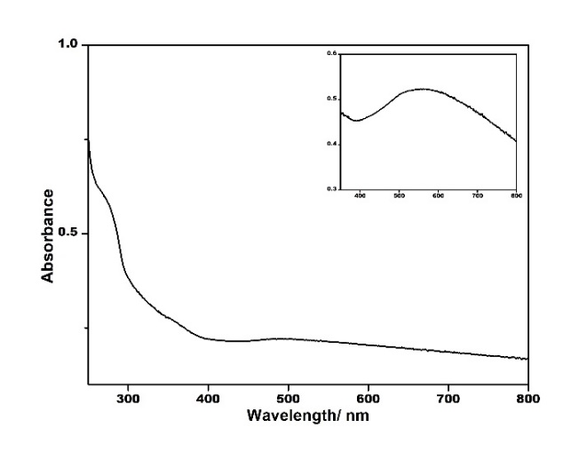

Figure 2. UV-visible spectrum of synthesized CuO NP. An expanded region of 500-600 nm hump is also shown

4.2. XRD Analysis

Figure 3 shows the X -ray diffraction pattern of the powdered CuO NPs samples. Eleven prominent peaks were observed at 32.47, 35.53, 38.78, 48.95, 53.59, 58.33, 61.61, 66.31, 68.10, 72.44, and 75.21 which correspond to {110}, {002}, {111}, {-202}, {020}, {202}, {-113}, {-311}, {113}, {311}, and {-222} reflections respectively of monoclinic Copper (II) Oxide **(**CuO) (JCPDSICDD No. 652309).

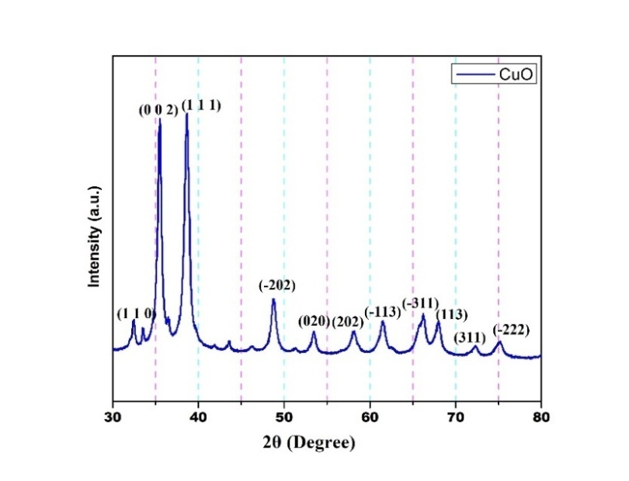

Figure 3.XRD spectrum of Copper (II) Oxide

4.3. Scanning Electron Microscopy (SEM)

SEM is a high-resolution imaging technique that provides a magnified view of the nanoparticles. It is used to determine the size and shape of the CuO nanoparticles. SEM images usually show spherical particles with a variable size distribution ranging from 11 to 70 nm.SEM image of CuO nanoparticle synthesized using curcumin has been shown in Figure 4a. The particle size distribution graph is shown in Figure 4b.

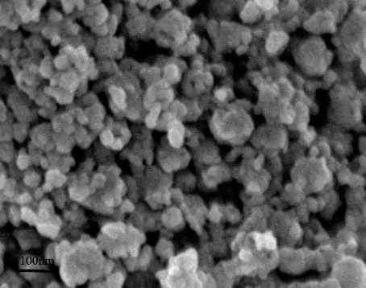 a)

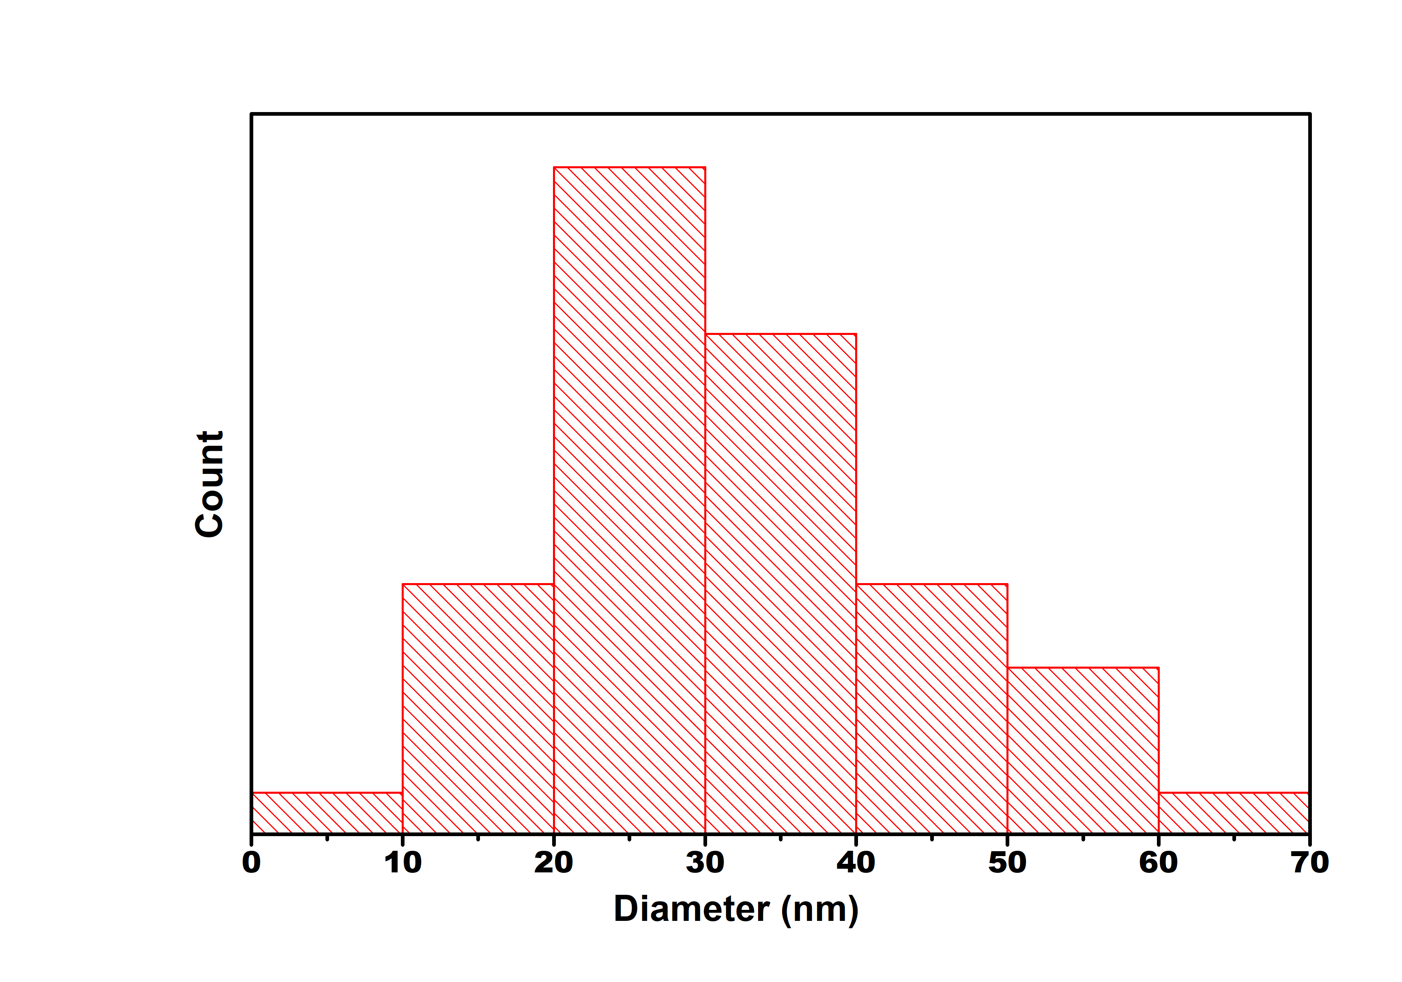 b)

Figure 4. (a)SEM image of CuO nanoparticle synthesized using curcumin (b) Particle size distribution graph of CuO NP

5. 5. Photocatalytic Application of CuO nanoparticle:

The photocatalytic activity of synthesized CuO samples was investigated by application of these nanoparticles as photocatalysts for the photo­degradation of very hazardous organic pollutant 4-nitrophenol(PNP) under dark and visible light irradiation and also under acidic and basic mediums. The UV-visible spectrum of 4-nitrophenol mainly consists of characteristic absorption peaks at 314 nm in an acidic medium and 400 nm in basic medium (due to the phenolate ion). Figure5(a) and (b)represent the UV-visible spectra of an aqueous solution of PNP in the presence of CuO NP, hydrogen peroxide and sodium hydroxide in dark and visible light irradiation conditions respectively.

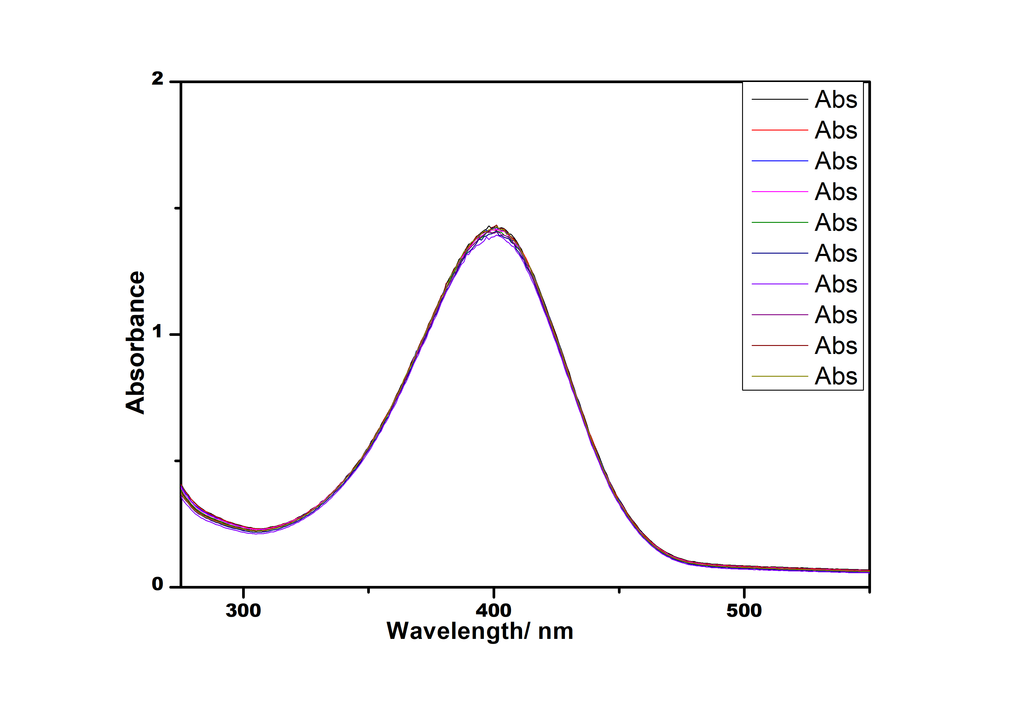a)

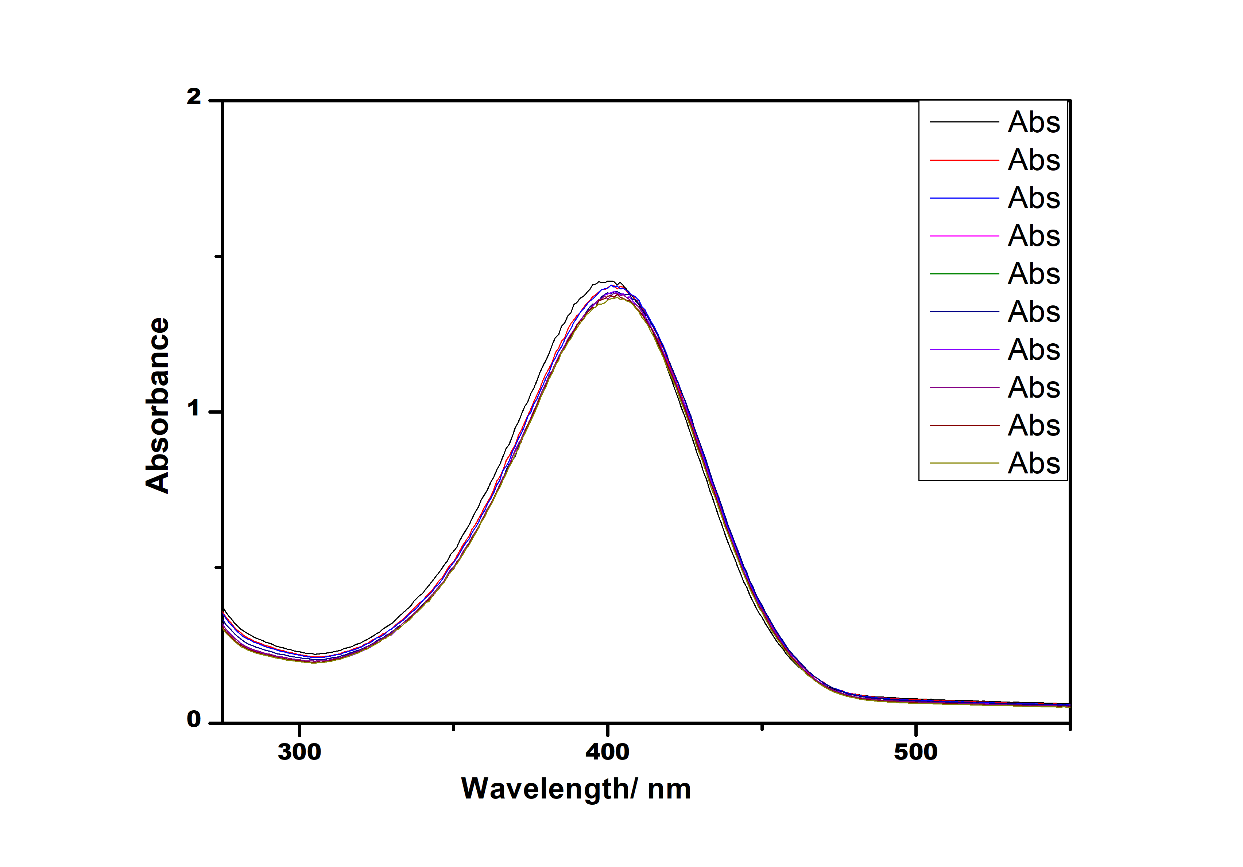b)

Figure 5. The photocatalytic reaction of CuO nanoparticle in the basic medium in (a) in absence of light (b) in the presence of LED light

Degradation of PNP was not observed in the basic medium in either dark or light conditions. Hence synthesized catalyst doesn’t work for the degradation of PNP in a basic medium. Figure 6 (a) and (b) represent the UV-visible spectra of an aqueous solution of PNP in the presence of CuO NP, hydrogen peroxide, and hydrochloric acid in dark and visible light irradiation conditions respectively. Spectra were recorded for 90 minutes but degradation was observed to be lesser in the absence of light as compared to visible light medium. It is clear from Fig. 5(a) &(b) that degradation of PNP is almost negligible in the absence and presence of light in the basic medium. The synthesized CuO demonstrated limited catalytic activity in alkaline conditions. This was primarily caused by the dissociation of PNP, which increased the repulsion between CuO and the PNP anions, as reported in earlier literature [26]. Whereas it shows slow degradation of PNP in the acidic medium in the absence of light and rapid degradation in the presence of light.

Initially, the degradation of PNP was studies in dark and found to show slow rate of degradation. Whereas when the reaction mixture was kept in the photocatalytic chamber under a cool white LED with visible light radiation, the reaction speeds up. A steady decrease in the intensity of peaks, on prolonged exposure to visible light, indicates gradual degradation of PNP with time. Photocata­lytic activity of CuO was recorded for 90min in both conditions and irradiated condition, PNP was found to be almost fully degraded to simpler ions. Hence the rate of degradation of PNP organic pollutants using CuO nanoparticlesis higher in visible light irradiated conditions in an acidic medium.

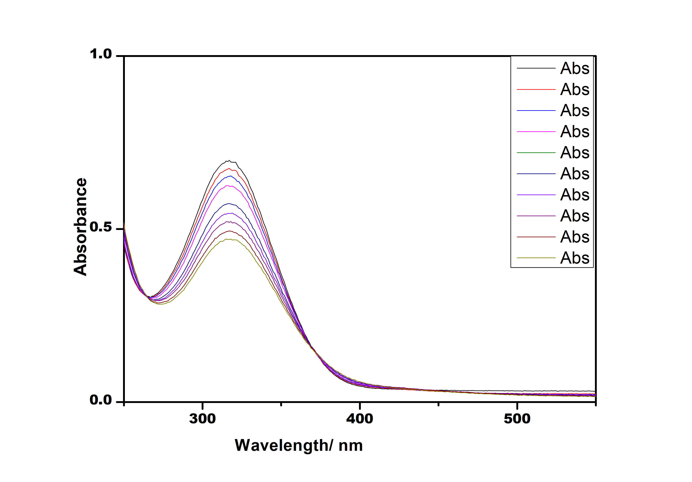a)

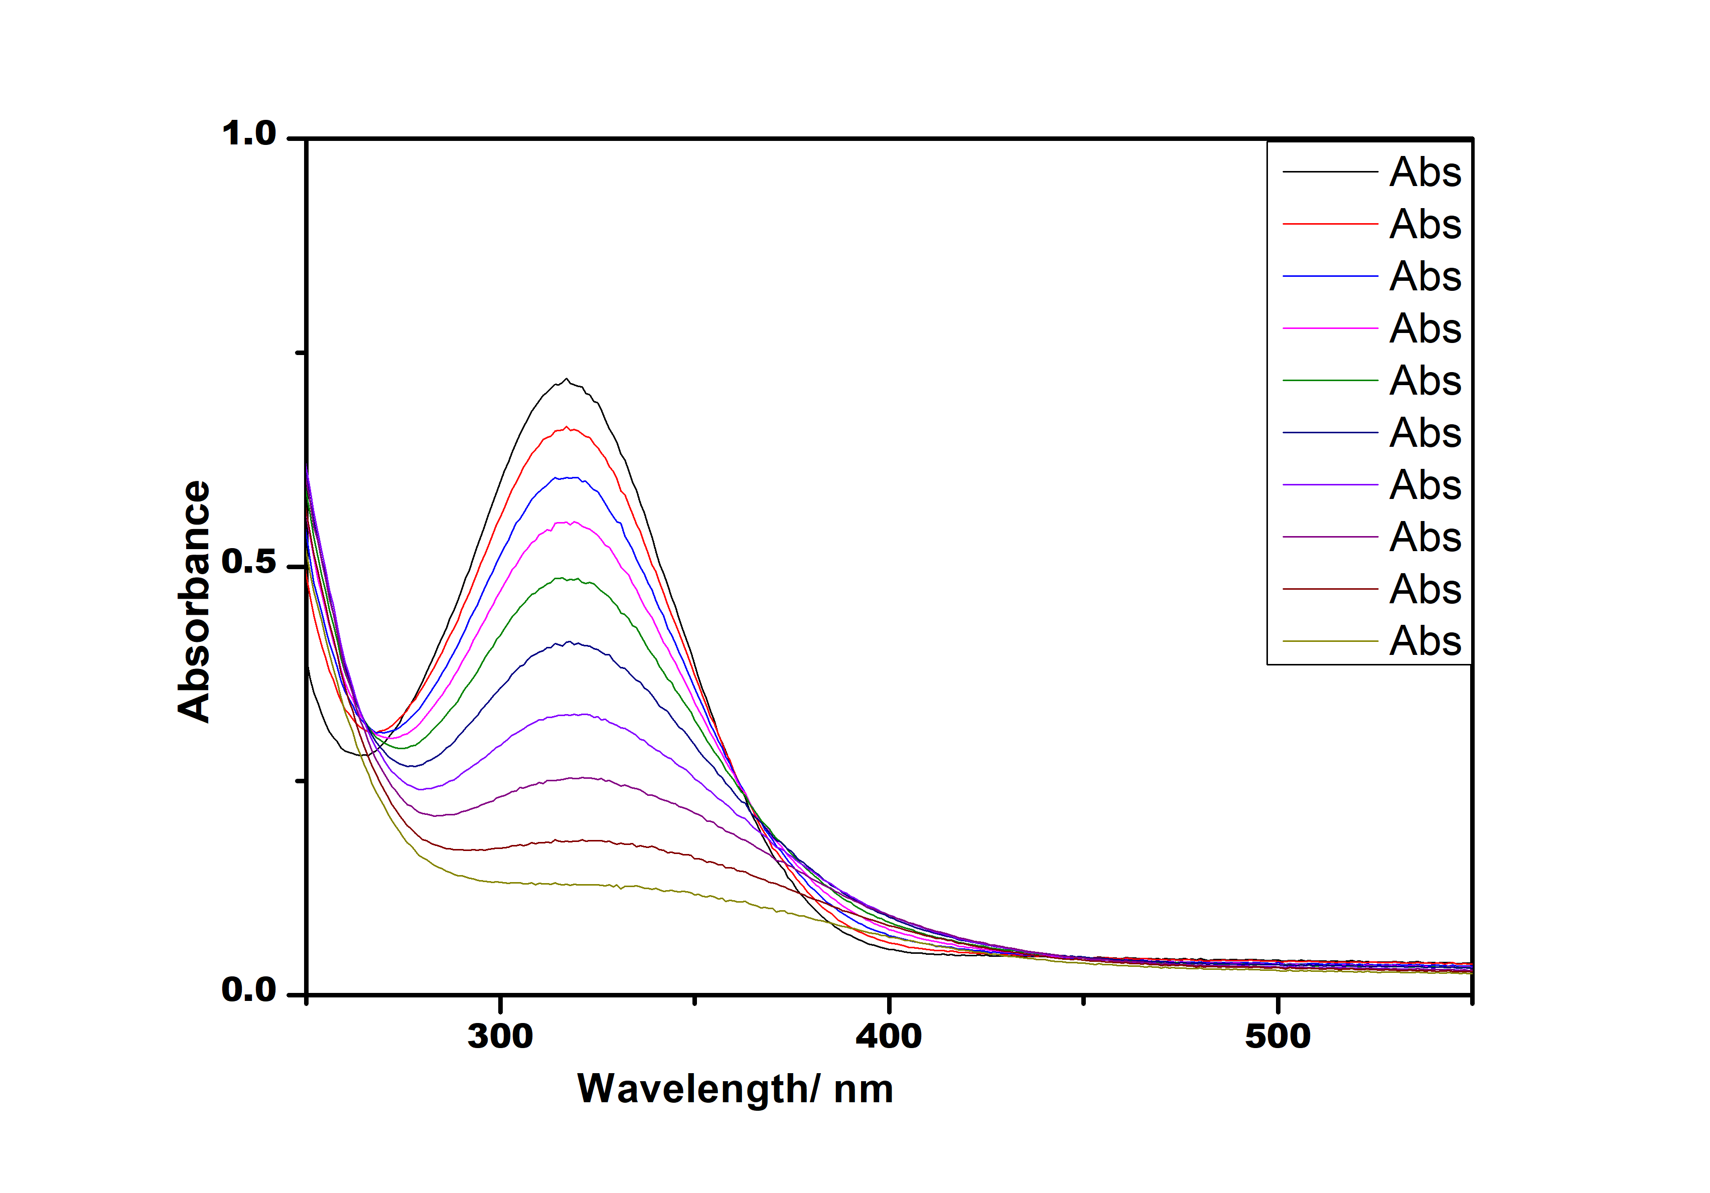b)

Figure 6. The photocatalytic reaction of CuO nanoparticle in the acidic medium (a) in the absence of LED light & (b) in the presence  
of LED light

6. Density Functional Theory calculation

Geometry optimization of CuO-curcumin carried out using Density Functional Theory (DFT) calculation using Gaussian 16 [27] program at B3LYP level [28] and using the LaNL2DZ basis set. The molecular optimized structure of CuO-cur­cumin moiety is shown in Figure 7(a). The distance between curcumin and CuOnanocluster was found to be 2.50Å indication strong interaction between CuO and curcumin moiety. Mulliken charge analy­sis of CuO-curcumin moiety was done at the same level of calculation and using a similar basis set and shown in Figure 7 (b). It was observed that the inner copper atoms are electropositive as shown by the light green color whereas outer copper atoms are less electropositive as compared to inner copper atoms. Oxygen atoms carry a negative charge as represented by a brown color or red color in Figure 7 (b). Mulliken charge distribution shows that the curcumin actives the outer layer of the nanocluster to enhance the rate of photocatalytic degradation in light by decreasing the band gap in CuO catalyst.

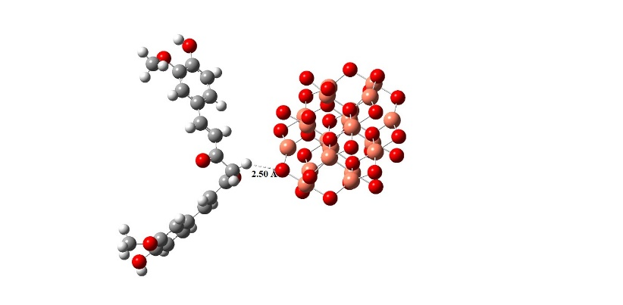 a)

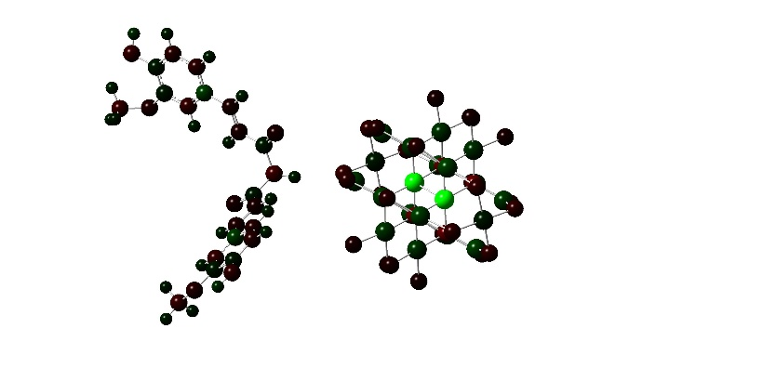b)

Figure 7.Optimized structure and Mulliken charge analysis of CuO-curcumin moiety

Figure 8 represents the electrostatic potential charge distribution on CuO-Curcumin moiety. It indicates that strong interaction is present between curcumin and CuOnanocluster, as the potential charge is distributed all over the molecule. The orange color represents the electronegative and the yellowish-green color represents the electro­positive charge distribution on the molecules.

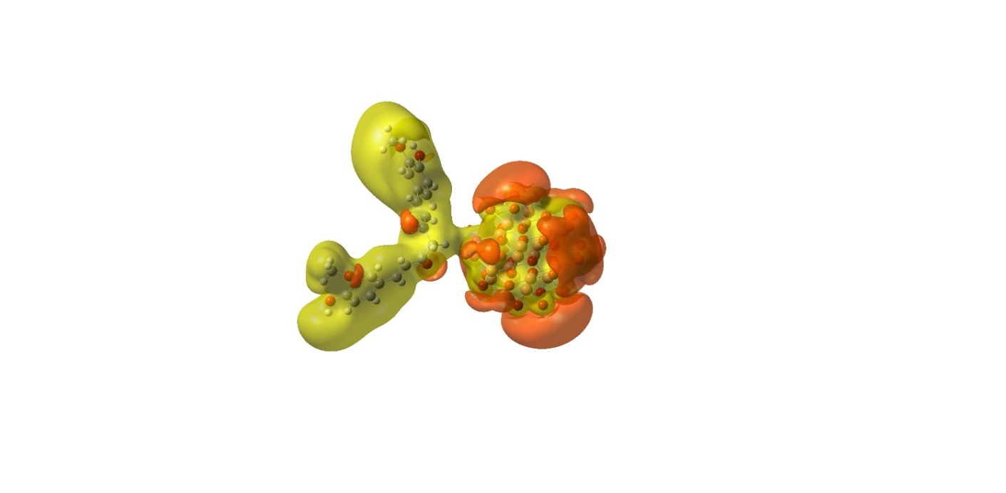

Figure 8. Electrostatic potential charge distribution on CuO-Curcumin

Figure 9 represents the frontier molecular orbital pictures of highest occupied molecular orbital (HOMO) and lowest unoccupied molecular orbital (LUMO). HOMO is localized mainly on curcumin moiety (π of Benzene and non-bonding orbitals of Oxygen), whereas LUMO is localized on π* of benzene and d-orbital of copper atoms of CuOnanoclusters.

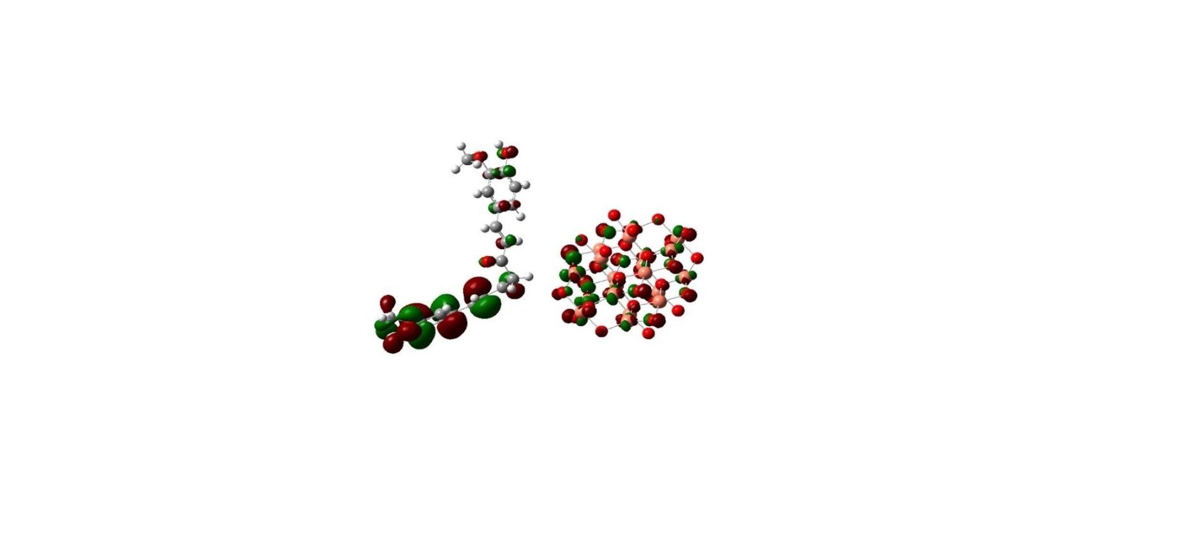

HOMO

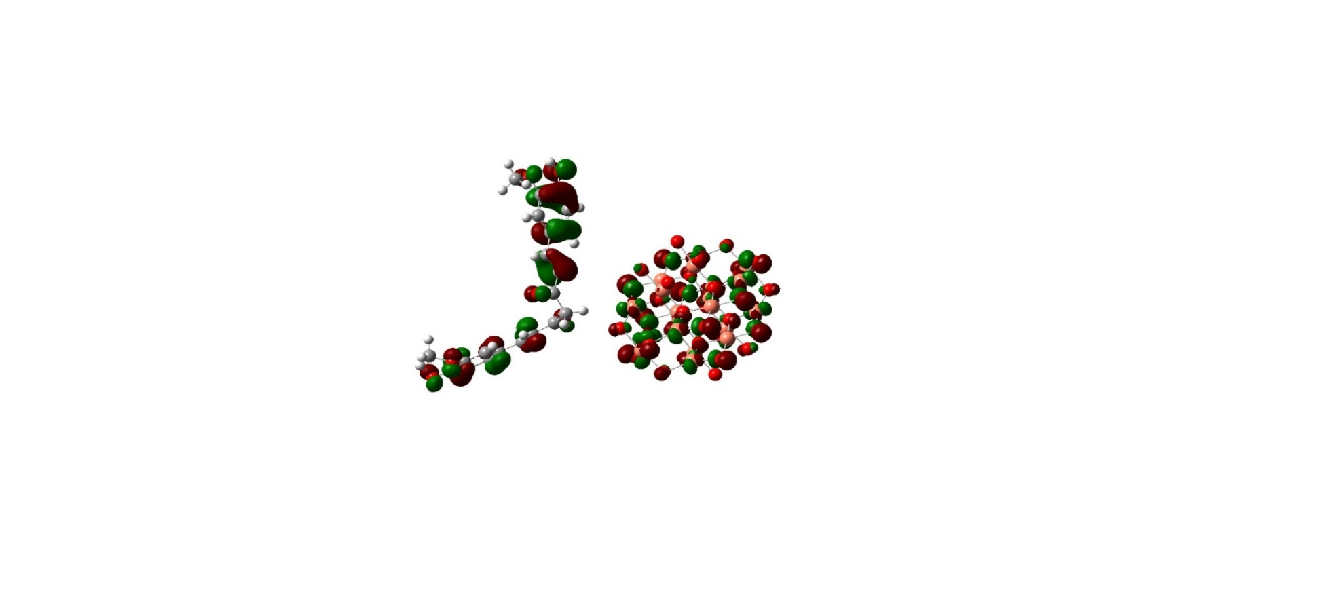

LUMO

Figure 9. Frontier Molecular Orbital picture of  
CuO-Curcumin

7. Conclusion

Copper oxide (CuO) nanoparticles have garne red considerable attention due to their unique properties and diverse range of applications. Researchers have developed various methods for synthesizing CuO nanoparticles, spanning physical, chemical, and biological approaches. These nanoparticles play a crucial role in fields such as electronics, energy storage, photo­catalysis, medicine, and materials science. This study presents a simple and rapid method for synthesizing CuO nanoparticles using curcumin and sodium borohydride. Synthesized CuO nanoparticle was used to study the photocatalytic degradation of PNP to 4-aminophenol. Photo­catalytic degradation of the organic pollutant 4-nitrophenol under different conditions, such as acidic and basic environments, with and without visible light irradiation has been studied. The findings reveal that in a basic environment, the degradation of p-nitrophenol remains minimal regardless of the presence of light. On the other hand, in an acidic environment, the degradation process occurs slowly in the absence of light, but significantly accelerates when exposed to light. CuO nanoparticles transform PNP into less harmful 4-aminophenol (4-AP). DFT calculation explains the charge distribution and interaction between curcumin and CuOnanocluster.

Acknowledgment

MLS thanks CIF IIT(BHU) for characterization facilities,CCIS, IIT (BHU) for computational facilities, and Gram BhartiCollegeRamgarh for research facilities.

Conflict of interests

The authors declare that they have no conflict of interest.

8. References

1. A. M. Al-Fa’ouri, M. H. Abu-Kharma, A. M. Awwad, M. K. Abugazleh (2023) Investigation of optical and structural properties of copper oxide nanoparticles synthesized via green method using Bougainvillea leaves extract,” Nano-Structures & Nano-Objects, 36, 101051. https://doi.org/10.1016/j.nanoso.2023.101051.
2. S. Faisal et al. (2021) Curcuma longa Mediated Synthesis of Copper Oxide, Nickel Oxide and Cu-Ni Bimetallic Hybrid Nanoparticles: Characterization and Evaluation for Antimicrobial, Anti-Parasitic and Cytotoxic Potentials,” Coatings, 11, 849. https://doi.org/10.3390/coatings11070849.
3. S. Aroob et al. (2023) Green Synthesis and Photocatalytic Dye Degradation Activity of CuO Nanoparticles,” 13, 502. https://doi.org/10.3390/catal13030502.
4. S. Naz, A. Gul, M. Zia, R. Javed (2023) Synthesis , biomedical applications , and toxicity of CuO nanoparticles,” Appl. Microbiol. Biotechnol., 107. https://doi.org/10.1007/s00253-023-12364-z.
5. M. Shukla, S. Pal, I. Sinha (2022) Ionic Liquid Functionalized Cu 2 O nanoparticles, 1262, 132961. https://doi.org/10.1016/j.molstruc.2022.132961.
6. P. Ramesh, A. Rajendran (2023) Photocatalytic dye degradation activities of green synthesis of cuprous oxide nanoparticles from Sargassum wightii extract, 6, 100208. https://doi.org/10.1016/j.chphi.2023.100208.
7. J. H N, K. G. Chandrappa, S. Fakrudeen, (2023) Green synthesis of CuO nanoparticles: A promising material for photocatalysis and electrochemical sensor, Sensors Int., 5, 100254. <https://doi.org/10.1016/j.sintl.2023.100254>.
8. H. Saha et al., (2024) Photocatalytic performance of CuO NPs: An experimental approach for process parameter optimization for Rh B dye, Results Mater., 24, 100614. https://doi.org/10.1016/j.rinma.2024.100614.
9. B. Coşkuner Filiz, (2020) The role of catalyst support on activity of copper oxide nanoparticles for reduction of 4-nitrophenol, Adv. Powder Technol., 31, 3845, https://doi.org/10.1016/j.apt.2020.07.026.
10. M. E. Grigore, E. R. Biscu, A. M. Holban, M. C. Gestal, A. M. Grumezescu, (2016) Methods of Synthesis, Properties and Biomedical Applications of CuO Nanoparticles, Pharmaceuticals, 9, 75. https://doi.org/10.3390/ph9040075
11. R. S. Hamida, M. A. Ali, A. Redhwan, M. M. Bin-Meferij (2020) Cyanobacteria - A Promising Platform in Green Nanotechnology: A Review on Nanoparticles Fabrication and Their Prospective Applications., Int. J. Nanomedicine, 15, 6033. <https://doi.org/10.2147/IJN.S256134>.
12. R. Ranjan, M. Shukla (2025) Curcumin-mediated synthesis of cuprous oxide nanoparticles and its photocatalytic application,” Next Mater., 6, 100481.

https://doi.org/10.1016/j.nxmate.2024.100481.

1. C. Yang, F. Xiao, J. Wang, X. Su (2014) Synthesis and microwave modification of CuO nanoparticles: crystallinity and morphological variations, catalysis, and gas sensing., J.Colloid Interface Sci., 435, 34-42. https://doi.org/10.1016/j.jcis.2014.08.044.
2. M. Ahamed, R. Lateef, M. J. Akhtar, P. Rajanahalli (2022) Dietary Antioxidant Curcumin Mitigates CuO Nanoparticle-Induced Cytotoxicity through the Oxidative Stress Pathway in Human Placental Cells,” Molecules, 27, 7378. https://doi.org/10.47750/pnr.2022.13.S10.753.
3. A. Mathew, A. Parveen, K. N. Pathade, A. Dhote, A. K. Nakkella, (2022) Green Synthesis And Pharma­cological Potential Of Curcumin,” 13, 6090.

https://doi.org/10.47750/pnr.2022.13.S10.753.

1. P. C. Okoye, S. O. Azi, T. F. Qahtan, T. O. Owolabi, T. A. Saleh, (2023) Synthesis, properties, and applications of doped and undoped CuO and Cu2O nanomaterials,” Mater. Today Chem., 30, 101513. https://doi.org/10.1016/j.mtchem.2023.101513.
2. H. T. Berede, et al. (2024) Photocatalytic activity of the biogenic mediated green synthesized CuO nanoparticles confined into MgAl LDH matrix,” Sci. Rep., 14, 2314. https://doi.org/10.1038/s41598-024-52547-w.
3. K. P. Jithul, K. S. Samra, (2022) Cupric Oxide based Supercapacitors: A Review,” J. Phys. Conf. Ser., 2267, 012120. https://doi.org/10.1088/1742-6596/2267/1/012120.
4. M. Devaraji, P. V Thanikachalam, K. Elumalai, (2024) The potential of copper oxide nanoparticles in nanomedicine: A comprehensive review, Biotechnol. Notes, 5, 80. <https://doi.org/10.1016/j.biotno.2024.06.001>.
5. M. J. Woźniak-Budych, K. Staszak, M. Staszak, (2023) Copper and Copper-Based Nanoparticles in Medi­cine-Perspectives and Challenges., Molecules, 28, 6687. https://doi.org/10.3390/molecules28186687.
6. H. Onyeaka, P. Passaretti, T. Miri, Z. T. Al-Sharify (2022) The safety of nanomaterials in food production and packaging, Curr. Res. Food Sci., 5, 763. https://doi.org/10.1016/j.crfs.2022.04.005.
7. A. A. Gvozdenko, et al., (2022) Synthesis of CuO nano­particles stabilized with gelatin for potential use in food packaging applications, Sci. Rep., 12, 12843. https://doi.org/10.1038/s41598-022-16878-w.
8. A. Bhattacharjee, M. Ahmaruzzaman (2016) CuO nanostructures: facile synthesis and applications for enhanced photodegradation of organic compounds and reduction of p-nitrophenol from aqueous phase, RSC Adv., 6, 41348, https://doi.org/10.1039/C6RA03624D.
9. I. Hasan, C. Shekhar, I. I. Bin Sharfan, R. A. Khan, A. Alsalme (2020) Ecofriendly Green Synthesis of the ZnO-Doped CuO@Alg Bionanocomposite for Efficient Oxidative Degradation of p-Nitrophenol, ACS Omega, 5, 32011. https://doi.org/10.1021/acsomega.0c04917.
10. K.Dulta, G.Koşarsoy Ağçeli, P.Chauhan, R. Jasrotia, P.K.Chauhan, J.O.Ighalo (2022) “Multifunctional CuO nanoparticles with enhanced photocatalytic dye degradation and antibacterial activity,” Sustain. Environ. Res., 32, 2. <https://doi.org/10.1186/s42834-021-00111-w>.
11. Y. Fan, et al. (2022) Effective photodegradation of 4-nitrophenol with CuO nano particles prepared by ionic liquids/water system,” Green Chem. Eng., 3, 15. https://doi.org/10.1016/j.gce.2021.07.009M.
12. J. Frisch, G. W. Trucks, H. B. Schlegel, G. E. Scuseria, M. A. Robb, J. R. Cheeseman, G. Scalmani, V. Barone, G. A. Petersson, H. Nakatsuji, X. Li, M. Caricato, A. V. Marenich, J. Bloino, B. G. Janesko, R. Gomperts, B. Mennucci, H. P. Hratchian, J. V. Ortiz, A. F. Izmaylov, J. L. Sonnenberg, D. Williams-Young, F. Ding, F. Lipparini, F. Egidi, J. Goings, B. Peng, A. Petrone, T. Henderson, D. Ranasinghe, V. G. Zakrzewski, J. Gao, N. Rega, G. Zheng, W. Liang, M. Hada, M. Ehara, K. Toyota, R. Fukuda, J. Hasegawa, M. Ishida, T. Nakajima, Y. Honda, O. Kitao, H. Nakai, T. Vreven, K. Throssell, J. A. Montgomery, Jr., J. E. Peralta, F. Ogliaro, M. J. Bearpark, J. J. Heyd, E. N. Brothers, K. N. Kudin, V. N. Staroverov, T. A. Keith, R. Kobayashi, J. Normand, K. Raghavachari, A. P. Rendell, J. C. Burant, S. S. Iyengar, J. Tomasi, M. Cossi, J. M. Millam, M. Klene, C. Adamo, R. Cammi, J. W. Ochterski, R. L. Martin, K. Morokuma, O. Farkas, J. B. Foresman, D. J. Fox (2016) Gaussian, Inc., Wallingford CT.
13. A. D. Becke (1993) Density-functional thermochemistry. III. The role of exact exchange,” J. Chem. Phys., 98, 5648. https://doi.org/10.1063/1.464913.

izvod

Sinteza nanočestica bakar (II) oksida: obećavajući  
materijal za fotokatalizu

Nanočestice bakarnog oksida (CuO) privukle su značajnu pažnju zbog svojih jedinstvenih svojstava i širokog spektra primene. Razvijene su različite metode za sintezu nanočestica CuO (NP), uključujući fizičke, hemijske i biološke metode. Ove nanočestice nalaze primenu u različitim oblastima, uključujući elektroniku, skladištenje energije, fotokatalizu, medicinu i nauku o materijalima. Ovaj rad izveštava o lakoj i brzoj sintezi CuOnanočestica po prvi put koristeći kurkumin kao stabilizator i natrijum borohidrid kao redukciono sredstvo. Sintetizovana nanočestica je okarakterisana pomoću merenja UV-vidljivog spektra i tehnika difrakcije rendgenskih zraka. Sintetizovani katalizator je korišćen za proučavanje fotokatalitičke degradacije veoma opasnog organskog zagađivača para-nitrofenola. (PNP) Studija je sprovedena u kiseloj i baznoj sredini pod tamnim i vidljivim zračenjem. U osnovnom okruženju, degradacija PNP ostaje gotovo beznačajna, bilo u prisustvu ili odsustvu svetlosti. Međutim, u kiseloj sredini, degradacija PNP se odvija sporim tempom kada nema svetlosti, ali se proces značajno ubrzava kada je izložen svetlosti. Proračun funkcionalne teorije gustine ukazuje na snažnu interakciju između kurkumina i CuO dela. To ukazuje da kurkumin stabilizuje nanočestice CuO i da će biti prilično stabilan dugo vremena. Takođe, to će olakšati lak prenos elektrona sa kurkumina na CuO NP smanjenjem pojasnog pojasa i poboljšanjem katalitičkih svojstava NP.

**Ključne reči**: nanočestice, CuO, fotokataliza, DFT proračun

Naučni rad

Rad primljen: 20.08.2024.

Rad korigovan: 29.01.2025.

Rad prihvaćen: 10.02.2025.

Madhulata Shukla: <https://orcid.org/0000-0002-4060-8729>

Ravi Ranjan: <https://orcid.org/0009-0004-3720-4514>

© 2025 Authors. Published by Engineering Society for Corrosion. This article is an open access article distributed under the terms and conditions of the Creative Commons Attribution 4.0 International license (<https://creativecommons.org/licenses/by/4.0/>)