Velumani Murugesan1, Mohanraj Rajendran2*, Loganathan Pattusamy3, Sakthieswaran Natarajan4

1Civil Engineering, K. S. Rangasamy College of Technology, Namakkal, Tamilnadu, India, 2Civil Engineering, Faculty of Engineering & Technology, SRM University, Delhi-NCR, Sonipat, Haryana, India, 3Civil Engineering, Excel Engineering College, Komarapalayam, Namakkal, Tamilnadu, India, 4Civil Engineering, P S R Engineering College, Sivakasi, Virudhunagar, Tamilnadu, India

Scientific paper

ISSN 0351-9465, E-ISSN 2466-2585

<https://doi.org/10.62638/ZasMat1197>

88x31

Zastita Materijala 66 ( )  
 (2025)

Enhancing corrosion resistance in concrete structures using *Euphorbia Tortilis* cactus extract by non-destructive testing

Abstract

This research investigates the corrosion resistance of reinforced concrete structures, a crucial aspect for ensuring their long-term performance and sustainability. Utilizing both the half-cell potential method and an accelerated corrosion test, the study introduces a novel approach by incorporating Euphorbia Tortilis Cactus (ETC) extract as an organic additive in concrete. The half-cell potential method involves measuring potential differences between steel reinforcement and an external electrode in a Cu/CuSO4 solution, revealing varied corrosion inhibition levels in different specimens. Notably, the introduction of ETC extract demonstrates unprecedented resistivity, showcasing a mere 10% probability of corrosion, even in atmospheric conditions. The accelerated corrosion test further emphasizes the novelty of the research. ETC concrete exhibits lower applied current and mass loss percentages compared to control mixes, indicating superior corrosion resistance and reduced porosity. This novel use of ETC extract in concrete enhances its durability and sustainability, providing valuable insights for developing resilient concrete structures amid increasing concerns about corrosion-induced deterioration in reinforced concrete constructions.

**Keywords**: Corrosion Resistance, Concrete Structures, Euphorbia Tortilis Cactus, Organic Additive, Sustainability

1. Introduction

The durability and longevity of reinforced concrete structures are critical considerations in civil engineering [1]. One of the primary challenges that compromise the performance of these stru­ctures is the insidious and pervasive impact of corrosion on steel reinforcement [2-5]. Corrosion-induced deterioration weakens the structural inte­grity of concrete elements and poses significant economic and environmental concerns [6]. In light of these challenges, this research endeavors to address the issue of corrosion in reinforced concrete by exploring innovative and sustainable solutions [7]. The introduction of organic additives in concrete technology represents a promising ave­nue for enhancing corrosion resistance [8]. In this context, the study focuses on the incorporation of Euphorbia Tortilis Cactus (ETC) extract as a novel and environmentally friendly admixture [9-13].

*Corresponding author: R. Mohanraj

E-mail: [rsrirammohan@srmuniversity.ac.in](mailto:rsrirammohan@srmuniversity.ac.in)

Paper received: 25. 07. 2024.

Paper corrected: 07. 01. 2025.

Paper accepted: 15. 01. 2025.

ETC, a readily available plant in certain regions, has shown promising properties that make it a potential candidate for mitigating corrosion in concrete structures [14,15]. Javaherdashti et al. [16] explores five mechanisms of microbiologically influenced corrosion and deterioration of reinforced concrete by algae. Microorganisms, including bacteria, algae, fungi, and lichens, significantly impact mineral materials' biodeterioration, especially stone, concrete, and glass, via aggressive biogenic acids and biofilms. Biotests, unlike chemical tests, reveal material resistance to microbial attack, showing notable weight loss variations and aiding in material selection for durability [17]. The use of bio-concrete for enhancing durability against aggressive conditions, motivated by insufficient data on its performance in extreme environments [18]. Key processes include chemical absorption from cement paste, biofilm formation attracting corrosive organisms, and photosynthetic-driven electrochemical cells, each contributing to concrete drying, cracking, and corrosion of both concrete and reinforcement steel [19]. This research embarks on a comprehensive investigation, employing both the half-cell potential method and an accelerated corrosion test, to assess the corrosion resistance of concrete enhanced with ETC extract [20]. Agboola et al. [21] examines corrosion of reinforcing steel in marine concrete, emphasizing the role of corrosion-inhibiting admixtures. It discusses classifications, applications, and the integration of functional nanostructured materials, highlighting their effectiveness in mitigating corrosion and enhancing durability in new constructions and repairs within the marine industry, alongside future research directions [22]. The study aims to provide quantitative insights into the effectiveness of ETC as a corrosion inhibitor and evaluate its potential as a sustainable alternative to traditional synthetic additives [23]. Through rigorous experimentation and analysis, this research seeks to contribute to the advancement of concrete technology, offering practical solutions to enhance the durability of structures in the face of corrosion challenges [24]. By exploring the unique properties of Euphorbia Tortilis Cactus, this study aligns with the broader objectives of promoting sustainability and eco-friendly practices in the construction industry [25-28]. Variations in soil composition, climate, and seasonal growth conditions can alter the concentrations of key active compounds, such as flavonoids, tannins, and saponins, within the plant [29]. These fluctuations may impact the extract’s effectiveness, as changes in the levels of antioxidative and film-forming constituents could affect the protective properties provided to the concrete [30]. Monteny et al. [31] reviews recent advancements in testing methods for biogenic sulfuric acid corrosion in concrete, highlighting differences between biogenic and chemical corrosion. It discusses various research approaches, including chemical tests, microbial simulations, and in situ exposure tests to assess material resistance [32,33]. Xu et al. [34] investigate the self-healing potential of ureolytic microbes embedded in ceramsite particles for repairing cracks in reinforced concrete. Results show complete healing of cracks up to 450 μm in 120 days, enhancing mechanical properties and effectively inhibiting reinforcement corrosion. Kanwal et al. [35] evaluates the impact of the calcifying bacterium *Bacillus safensis* and biochar on the mechanical and transport properties of cementitious composites. Results show significant enhancements in flexural and compressive strength, a healing degree increase, and 95.18% corrosion inhibition, suggesting a sustainable approach for improving durability in reinforced concrete.

2. Research Significant

The significance of this research lies in its multifaceted contributions to the field of concrete technology, addressing critical challenges associated with corrosion in reinforced concrete structures. The primary objectives of this study are intricately connected to the broader significance, offering solutions to enhance durability, sustainability, and environmental friendliness in construction practices.

Corrosion Mitigation: The research aims to provide concrete structures with improved resistance to corrosion, a pervasive issue that compromises the longevity and structural integrity of reinforced concrete. By investigating the potential of Euphorbia Tortilis Cactus (ETC) extract as an organic additive, the study seeks to offer an innovative and eco-friendly solution to mitigate corrosion-related deterioration.

Novel Organic Additive: The incorporation of ETC extract represents a novel approach to concrete admixtures. The research strives to establish the efficacy of this organic additive in enhancing the corrosion resistance of concrete, providing an alternative to traditional synthetic additives, and contributing to the development of sustainable construction materials.

Half-Cell Potential Method Evaluation: The utilization of the half-cell potential method serves as a key objective, offering a quantitative assessment of the probability of corrosion in different concrete specimens. The significance lies in providing a reliable and standardized technique to evaluate the effectiveness of corrosion inhibition, enabling comparisons and insights into the performance of diverse concrete mixes.

Accelerated Corrosion Test: Through the accelerated corrosion test, the research aims to simulate and assess the performance of ETC concrete under harsh environmental conditions. The outcomes will contribute valuable data on the material's resistance to corrosion, aiding in the formulation of durable concrete mixes suitable for aggressive environments.

Sustainable Construction Practices: The broader significance of this research extends to the promotion of sustainable construction practices. By exploring environmentally friendly alternatives, such as ETC extract, the study aligns with global efforts to reduce the ecological footprint of construction activities and advance the development of green building materials.

This research's significance lies in its potential to revolutionize concrete technology by introducing a natural, sustainable, and effective corrosion mitigation strategy. The outlined objectives collectively contribute to the advancement of construction materials, fostering durability, resilience, and environmental responsibility in the built environment.

3. Materials and methodology

In this research, Ordinary Portland cement, grade 53, conforming to IS: 12269 – 2013, IS: 4032-2013, and IS:4031-2013, was utilized. The cement underwent various tests to ensure its suitability, including fineness, normal consistency, setting time, soundness, and compressive strength at different curing periods [36]. The results indicated that the selected cement met the requirements, ensuring the desired properties of the ETC concrete [37]. Aggregates, accounting for 70 to 80 percent of concrete volume, play a crucial role in the material's production [38]. Fine aggregates, sourced from the locally available Karur River, were subjected to tests outlined in IS: 2386 (Part 3 & 4) [39].

The results confirmed that the fine aggregates met the specifications, falling under Zone III. Coarse aggregates, chosen for durability and low permeability, were tested according to IS: 2386-2012 and IS 383-2012 [40, 41]. The properties showcased the suitability of the coarse aggregates for ETC concrete [42]. Water, another vital component, should be free from salts and impurities that could adversely affect the chemical reactions in concrete. The water used in this study, sourced from the Cauvery River, adhered to the specifications of IS: 456-2000 [43]. A unique aspect of this study involved the use of Euphorbia Tortilis Cactus extract as a natural organic additive. Collected from Pallakapalayam in Tamilnadu, the cactus extract underwent thorough analysis, revealing its composition of fats, proteins, polysaccharides, and water [44]. The extract was added to the water at varying concentrations (1%, 3%, 5%, 7%, and 9%) to explore its impact on the ETC concrete [45]. With 5.2% polysaccharides and 1.9% proteins, the organic additive offers a unique and environmentally friendly alternative to synthetic additives [46]. Finally, steel reinforcement is a critical component in concrete construction, providing strength and durability [47]. In this study, Fe415 grade steel was chosen for its favorable characteristics in flexural strength and deflection tests. The primary constituents, Flavonoids, Tannins, Alkaloids, Saponins and Lipid-like Waxes are contributing to corrosion inhibition in ETC extract [48]. Thus, the Euphorbia Tortilis Cactus concrete in this study is meticulously designed, considering the properties of cement, aggregates, water, organic additives, and steel reinforcement [49]. The comprehensive testing and analysis of each component ensure that the ETC concrete meets the specified standards for strength, durability, and environmental sustainability. This research contributes to the ongoing efforts to explore eco-friendly alternatives in the field of concrete technology.

4. Experimental Study

Steel reinforcement provides the tensile qualities needed in structural concrete. Wind, traffic, dead loads, and thermal cycling do not induce the breakdown of concrete structures subjected to tension and flexural stresses. However, when the reinforcement corrodes, connection is lost, which causes the concrete to rust and eventually spall and delaminate. If not stopped, the structure's integrity can be compromised. The strength capability of the structure decreases as a result of the reduction in steel's cross-sectional area.

4.1. Corrosion process

Corrosion is a term used to describe the degradation of a metal or alloy brought on by oxidation, a chemical process that creates iron oxides and leads them to break away from the base. Concrete deteriorates due to reinforcing corrosion, which causes spots, cracks, and spalling, reducing the material's strength and dimensions [50]. As a result, in recent years more emphasis has been paid to the steel reinforcement in ETC concrete. The thermal power plant's operational state and the calibre of the coal utilised both affect the ETC quality [51]. Ingress of carbonization and chloride ions is the main cause of corrosion in ETC concrete. In ETC concrete, the corrosion of the reinforcing steel occurs electrochemically in the presence of oxygen and water [52]. Corrosion is prevented on the steel reinforcement by the highly alkaline atmosphere [53]. Rust (Ferric hydroxides and Ferric oxides) that are present at the interface between concrete and reinforcement and have a volume 3 to 6 times greater than Fe ions are the cause of concrete deterioration [54]. Internal tensions caused by rusting in a concrete part cause fractures to appear on the exterior of the cement composite, which then causes harm to the structure and, ultimately, causes the collapse of the entire structure [55].

Figure 1 shows the Galvanic Corrosion Cell. It takes flow current and several other chemical processes to prevent steel reinforcement corrosion in concrete, which is an electrochemical process. An electrochemical cell is set up when the potential on the concrete reinforcement changes. A galvanic cell of corrosion must have the following three components.

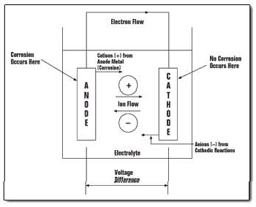

Figure 1.Galvanic corrosion cell

Anode

The anode is the area on a steel bar inserted in concrete where negatively charged electrons enter the cathode through the steel reinforcement and ferrous ions from the steel are lost to the solution. The anodic reaction is the name for the aforementioned process.

Cathode

The location of a steel reinforcement embedded in concrete is also known as the cat­hode. Anywhere the electrolytes (water and oxy­gen) negatively charged electrons, or e-, are absorbed, they join with the water and oxygen to form hydroxyl group ions or OH-. The reaction des­cribed above is referred to as a cathodic reaction.

Through the electrolyte, this hydroxyl group ion OH- combines with ferrous ions Fe2+ to form ferrous hydroxide Fe (OH)2. Fe (OH)3 is produced when they react with the solution's water (H2O) and oxygen (O). More oxidation transforms this into rust.

Electrolyte

Between the anode and cathode, current (electron) can flow more easily through this material. Concrete can act as an electrolyte when it has sufficient conduction after being subjected to wet and dry cycles. The anode and cathode are frequently placed close together or can be separated by a certain amount of space. The corrosion process requires both cathodic and anodic reactions to take place. The responses happen at the same time.

4.2. Corrosion mechanism

Concrete reinforcement corrosion is challenging. Similar to a basic battery, this electrochemical process uses electricity. An electrochemical cell is established within the reinforcement when the potential for steel reinforcement in concrete changes. The anode is the portion of the steel that is the most negatively charged, and the cathode is the opposite (positively charged). With the reinforcement completing the circuit and the concrete acting as the electrolyte, the concrete can conduct current positively charged ferrous ions generated by the anode combine with the ions of the cathode's hydroxyl group (OH-) in the presence of water and oxygen. Once in the electrolyte, they move through it and interact with ferrous ions to form Fe (OH), which is further oxidised to form rust [56]. This expansive reaction results in a volume of rust that is six times larger than the initial volume of ferrous ion. The collected amount of rust causes internal tensions in the concrete, which results in cracking, spalling, or delamination of the concrete on the cap. Concrete loses its integrity in these things. The entire structure collapsed as a result of the concrete member's altered cross section. Figure 2 depicts the rebar corrosion.

In a newly built structure, the concrete's alkalinity is sufficient to establish that the steel is in a passive state and will not corrode. If specific ions don't attack the steel, these chemicals, with a pH scale of 13–14, provide a passive coating that will protect the metal. In this film, it is demonstrated that chloride ions exchange hydroxyl group ions, causing localised pitting and the onset of the corrosion process. In order to identify the corrosion mechanism in various reinforced concrete types that contain ETC and steel bar, extensive experimental tests were undertaken, and the results are reported in this work. It also informs on the research done to determine how corrosion attacks on ETC concrete structures affected the various curing conditions. With 20 percent, 30 percent, and 40 percent of the weight of cement (Dalmia), concrete mixes were made using samples made of 16 mm diameter steel bars (TATA Tiscon) that were 100 mm long and had a 25 mm clear cover. In embedded steel bars, the corrosion process was examined. Using ACM Instruments, half-cell potential and Accelerated corrosion techniques were conducted.

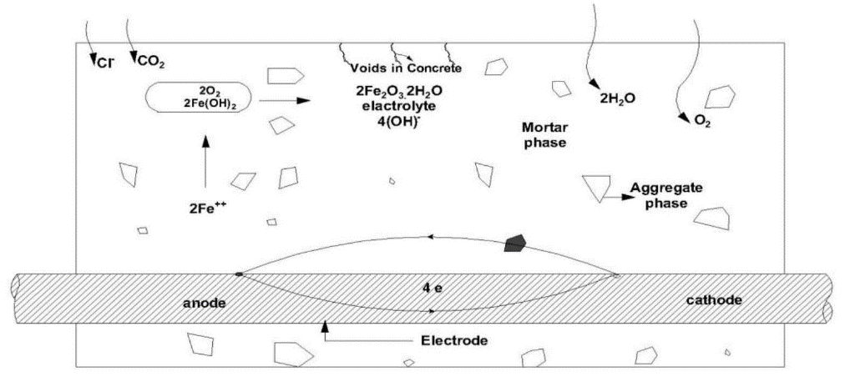

Figure 2. Rebar corrosion

4.3 Half-cell potential method

To make sure the concrete is still strong and durable enough, it is frequently necessary to inspect and test existing concrete structures. Anodic and cathodic activity will be encouraged at various locations throughout the reinforcement if the steel is de-passivated by carbonation or intrusion of chlorides [57]. At the anodes, where metal ion oxidation occurs, metal is dissolved, leading to the formation of metal oxide corrosion products. A reduction process takes place simultaneously with the release of electrons, which are then carried by an electrical current via the metallic reinforcement to the cathodic site. An appropriate half-cell electrode can be used to detect this fluctuation in electrical potential throughout the length of the corroding reinforcement that is connected to the flow of current. Anodic regions for steel in concrete often have higher negative potentials than cathodic zones, which have lower negative potentials. Half-cell probes are made of an electrolyte and conductor that may be held up to the concrete surface; the concrete and reinforcing make up the other half of the cell. They work as a unit to create a full electrical cell that produces a mill voltmeter-measurable voltage. The schematic view of the half-cell potential method is shown in Figure 3.

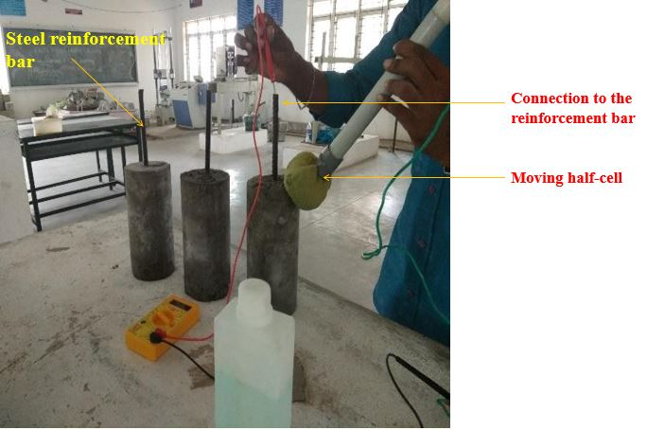

Figure 3. Typical Half-cell potential measurement arrangement

Table 1 Corrosion probability percentage

|  |  |
| --- | --- |
| Half-cell potential (mV)  relative to | Chance of corrosion  (in %) |
| < 200 | 10 % |
| 200 to 350 | 50 % |
| > 350 | 90 % |

A voltmeter was used to measure the potential difference between the steel reinforcement and the external electrode in this procedure. A metal rod is immersed in Cu/CuSO4 solution in the half-cell. A voltmeter connects the metal rod to the reinforcement steel. To generate an exact value, steel reinforcement, and outside electrodes were connected through wet concrete protection. The availability of oxygen, concrete resistivity, and cover thickness all stimulus the outcome of a half-cell potential test. Half-cell potential measurements only provide a "probability" of rebar corrosion occurring; they do not provide an estimate of its rate.

4.4 Accelerated corrosion test

According to ASTM C 876 criteria, the corrosion test measures how steadily steel degrades while exposed to external current. Since the corrosion analysis is based on a quick examination of the performance of steel without waiting for a long time, this test is also known as an accelerated corrosion test. The beams of 1 m in length and cross-section 150 × 200 mm were cast for each optimum ETC mix and the control mix (total of 6 numbers). The tension reinforcement was wound with wires at two points so that uniform corrosion was initiated in the rebars [58, 59]. After that, the specimen is submerged in a container containing water that has been thoroughly diluted with 5 percent sodium chloride (NaCl). The RCC specimen under investigation is perfectly enclosed by a steel sheet of extremely thin thickness.

The supply was connected so that the positive end went to the steel sheet and the negative to the steel embedded in concrete. After passing a 12V external supply to the connection, six days of behaviour analysis follow. The embedded steel then corrodes over time as a result of the power source and a reaction to the temperature of the environment. The output of the rusted steel in the concrete was then observed using a half-cell potential metre. In a half-cell potential metre, a glass tube containing a copper rod is filled with diluted copper sulphate solution. The sponge will be near the bottom of the tube, below the porous stopper. Over the concrete, the sponge-like arrangement was put, and the steel was attached to the point's other end. Figure 4 displays concrete corrosion and its interpolation analysis.

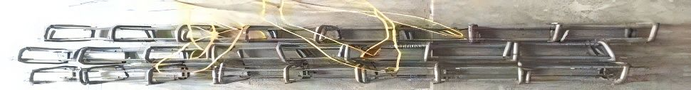

Figure 4. CorrosionTestAnalysisasperASTMC876specifications

Calculation of Corrosion

Based on the Faraday law, the theoretical mass of rust (Mth) is determined as follows

$M_{th}=\frac{WI_{app}T}{F}$ (1)

Where *M*th is the theoretical mass of rustormassloss (g); *W*–the equivalent weight of steel (27.925g); *I*app– the current applied (A); *T*– the period of induced corrosion (s); *F* – the Faraday constant (96487 As).

After the corrosion test, by breaking the specimens and rebars were extracted. According to the gravimetric test (ASTM G1), the actual mass (Mac) of rust is calculated:

$M_{ac}=\frac{W_{i}-W_{f}}{πDL}$ (2)

Where *W*i is the initial weight of the rebar; *W*f – the weight of the rebar after corrosion; *D* – the diameter of the rebar, and *L* – the length of the rebar.

Assuming that the actual and theoretical mass of rust are equal (i.e., Icorr = Iapp) and by equating Mac and Mth the equivalent corrosion current (Icorr) is calculated:

$I_{corr}=\frac{W_{i}-W_{f}}{W_{t}}$ (3)

The percentage weight loss (ρ) is calculated as:

(4)

5. CORROSION TEST RESULTS ON ETC CONCRETE

5.1. Half-cell potential method

The fundamental disadvantage of RC concrete structures is that their performance deteriorates when they are exposed to the action of corrosion. To evaluate the probability of corrosion in concrete, the half-cell potential approach was used. A voltmeter was used to measure the potential difference between the steel reinforcement and the external electrode in this procedure. A metal rod is immersed in Cu/CuSO4 solution in the half-cell. A voltmeter connects the metal rod to the reinforcement steel. The high-accelerated corrosion experiment's driving force, external voltage, was maintained at a constant level throughout. To generate an exact value, steel reinforcement, and outside electrodes were connected through wet concrete protection. The availability of oxygen, concrete resistivity, and cover thickness all stimulus the outcome of a half-cell potential test. For determining the possibility of corrosion, the potentials were measured an average of many measurements obtained from different sites on the same surface or at any place on the surface was used. According to ASTM C876, the half-cell potential test was carried out; the graphical variations are shown in Figure 5 and Figure 6 for M 20 and M 25, respectively. For the M20 concrete, the half-cell potential measurements were as follows: -2715mV, -216mV, -178mV, -142mV, -121mV, and -97mV; and for the M25 concrete, -255mV, -196mV, -157mV, 126mV, -98mV, and -76mV. This shows that various specimens have variable corrosion inhibition. After obtaining the results, the contour was plotted on a graph to identify the high corrosion activity. Concrete with ETC showed the highest level of resistivity. Hence regarding the test result, it shows that the corrosion on the ETC Concrete was not affected by any corrosion agent even after placing it in atmospheric conditions and the probability of corrosion was 10% in the concrete.

5.2. Accelerated corrosion test

For the current capacity of the circuit, the current applied to the fiber specimens was found to be lesser than that of the control specimens. From Table 1, it can be understood that the conductance of the ETC concrete specimens was lesser compared to control specimens, which in turn indicates higher porosity of control specimens. In the accelerated corrosion test, three distinct concrete mixes were subjected to corrosion evaluation, with results outlined in Table 1. The reference concrete exhibited an average applied current (Iapp) of 1.02 As, experiencing a weight loss of 120g over the testing period. The theoretical weight loss, calculated at 126.56g, resulted in a 4.22% weight loss and a corresponding equivalent corrosion current (Icorr) of 0.95 As. The ETC9M20 concrete mix, incorporating Euphorbia Tortilis Cactus (ETC) extract, demonstrated an Iapp of 1.19 As, with a weight loss of 193g, yielding a 5.06% weight loss and an Icorr of 1.14 As. Similarly, for the ETC9M25 mix, the Iapp was 1.57 As, accompanied by a weight loss of 179g, translating to a 6.24% weight loss and an Icorr of 1.42 As. These results collectively highlight the variations in weight loss percentages and equivalent corrosion currents among the concrete mixes, emphasizing the potential of ETC extract in enhancing corrosion resistance, particularly in the M20 mix where the inhibitory effect is most pronounced. Thus, it can be concluded that ETC concrete has higher corrosion resistance and it can effectively be used in an aggressive environment. The mass loss percentages of ETC concrete specimens were found to be lesser than the control mix cast without ETC

Table 1. Accelerated corrosion test results

|  |  |  |  |  |  |  |  |  |
| --- | --- | --- | --- | --- | --- | --- | --- | --- |
| Beam ID | Average  *I*app(As) (g) | Initial weight  (g) | Final weight (g) | Weight loss (g) | Theoretical  Weight loss (g) | Weight loss (%) | Weight loss (%) | Equivalent corrosion current *I*corr(As) |
| Reference Concrete | 1.02 | 2823 | 2703 | 120 | 126.56 | 4.22 | 4.48 | 0.95 |
| ETC9 M 20 | 1.19 | 2858 | 2665 | 193 | 150.11 | 5.06 | 5.35 | 1.14 |
| ETC9 M 25 | 1.57 | 2836 | 2657 | 179 | 97.84 | 6.24 | 6.98 | 1.42 |

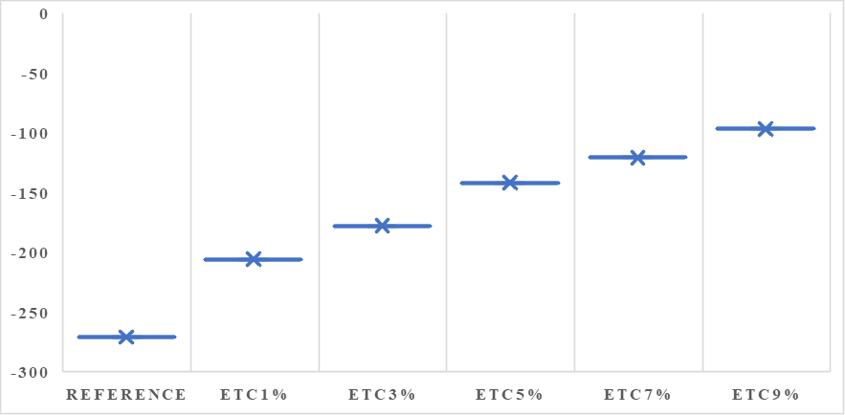

Figure 5. Rate of corrosion in M20 concrete

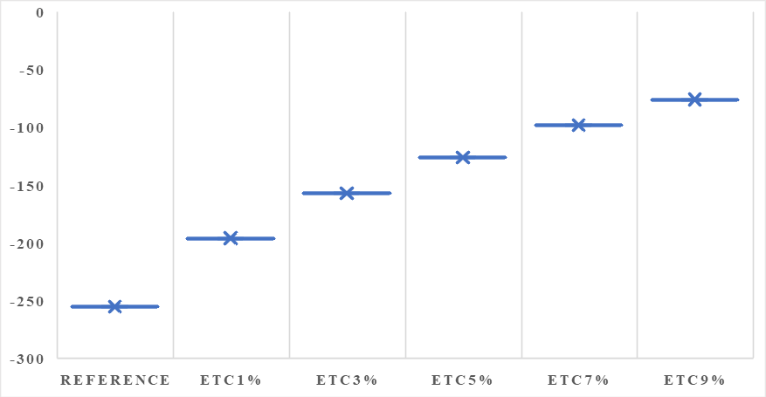

Figure 6. Rate of corrosion in M25 concrete

5.3. Chemical interactions and mechanisms by which Euphorbia Tortilis cactus extract enhances corrosion resistance in concrete structures

Euphorbia Tortilis extract contains a high concentration of flavonoids, alkaloids, and tannins, which possess antioxidative properties. These compounds can neutralize free radicals and reduce oxygen availability at the steel-concrete interface, which is essential for the initiation and progression of corrosion, equation 5. The extract effectively slows down the electrochemical reactions that drive corrosion by diminishing the oxygen concentration. The bioactive compounds in ETC extract can adsorb onto the steel reinforcement surface, forming a thin protective layer (Eqn. 6). This film acts as a physical barrier, reducing the interaction between the steel and corrosive agents such as chloride ions and water. The protective film is enhanced by the presence of tannins and saponins, which are known for their film-forming and adhesive properties.ETC extract contains waxy and lipid-like compounds (Eqn. 7) that increase the hydrophobicity of the concrete matrix. This reduces water permeability within the concrete, thereby minimizing the migration of moisture and dissolved ions to the steel reinforcement. Lower permeability reduces the concrete's porosity and its potential to conduct ions, directly decreasing the likelihood of corrosion initiation. Euphorbia Tortilis contains certain alkaline compounds that help stabilize the pH levels within concrete. A stable, high pH environment within the concrete prevents the passivation layer on the steel from dissolving, which is critical for corrosion protection (Eqn. 8). This buffering effect also maintains the basicity of the surrounding concrete, further deterring acidic conditions that might accelerate corrosion.

Flavonoid  (reduced)+⋅OH→Flavonoid  (oxidized)+H2O (5)

Tannin + Fe2+ → Tannin - Fe  complex  (protective  film) (6)

CnH2n + 2O + H2O → Hydrophobic  layer  (repels  water) (7)

K+ + Cl− → KCl  (reduced  chloride  concentration) (8)

Ion Exchange and Chelation

Some compounds within the Euphorbia Tortilis extract exhibit chelating abilities, binding to metal ions that might otherwise catalyze the breakdown of the passivating film on the steel. Chelation of chloride ions or other aggressive ions reduces their free concentration, thus decreasing their availability to participate in the corrosive process (Eqn. 9).

Tannin + Cl − → Tannin - Cl complex (chelated form)   
 (9)

The complex mix of bioactive compounds in the ETC extract likely acts synergistically to enhance corrosion resistance. While individual compounds have their protective roles, their combined effect can produce a stronger, more cohesive inhibition mechanism. This may include the combination of antioxidative actions, film formation, and hydrophobic effects, offering comprehensive protection against multiple corrosion factors.

Outcomes based on the observed impro­vements in corrosion resistance include the improved corrosion resistance of ETC-treated concrete, as evidenced by lower weight loss percentages and lower corrosion currents (Icorr) compared to untreated concrete, indicating a slower degradation rate of steel reinforcement. This slowdown could extend the concrete’s service life by reducing the frequency of corrosion-induced damage, potentially extending the lifespan by 10-20% or more, depending on the exposure environment. ETC extract’s hydrophobic properties reduce water permeability and chloride ion ingress, both critical factors in corrosion initiation. With lower chloride diffusion rates, the initiation phase of corrosion could be significantly delayed, particularly in marine or de-icing salt environments, potentially adding another 5-10 years to the concrete’s expected lifespan. For structures in harsh climates or industrial settings, the antioxidative and passivating effects of the extract could extend service life even further. In such environments, ETC-treated concrete might show an extended service life of 15-30% beyond untreated concrete, translating to an additional 10-15 years in typical reinforced concrete structures exposed to these conditions.Reduced maintenance requirements due to delayed corrosion initiation and progression mean fewer repairs or replacements, further contributing to the longevity of structures and offering significant cost savings over the structure’s lifetime.

6. Conclusion

The possibility of corrosion occurrence was evaluated by the half-cell potential method and accelerated corrosion test. The following conclusions are reached based on the outcomes of the experimental tests:

* The minimum possibility of corrosion (36%) was observed at an optimum level of dosage when compared to reference concrete. Results showed a better inhibiting effect of corrosion rate on steel rods and reduced weight loss.
* In conclusion, the scientific investigation has yielded compelling numerical evidence supporting the enhanced corrosion resistance of concrete structures through the incorporation of Euphorbia Tortilis Cactus (ETC) extract. The half-cell potential method, conducted according to ASTM C876, revealed notable variations in corrosion inhibition across specimens. For M20 concrete, half-cell potential measurements ranged from -2715mV to -97mV, and for M25 concrete, values ranged from -255mV to -76mV. Significantly, ETC concrete consistently exhibited the highest resistivity, with a mere 10% probability of corrosion.
* The accelerated corrosion test further substantiates these findings, emphasizing the novel and sustainable nature of ETC concrete. In the case of ETC9M20, the weight loss percentage was 5.06%, and for ETC9M25, it was 6.24%. In comparison, the reference concrete showed a weight loss percentage of 4.22%. This numerical evidence underscores the superior corrosion resistance and reduced porosity of ETC concrete, indicating its efficacy in aggressive environments.
* The study's quantitative results contribute to the scientific understanding of corrosion mitigation strategies in concrete, emphasizing the numerical advantages of incorporating Euphorbia Tortilis Cactus extract. These findings bear significant implications for the development of durable and sustainable concrete structures in the construction industry. Further exploration and application of these numerical insights could drive advancements in eco-friendly construction practices.

7. Reference

1. Y. Song, K. Chetty, U. Garbe, J. Wei, H. Bu, L. O'moore,...G.Jiang (2021) A novel granular sludge-based and highly corrosion-resistant bio-concrete in sewers. *Science of The Total Environment*, *791*, 148270.

https://doi.org/10.1016/j.scitotenv.2021.148270

1. N. Roghanian, N. Banthia (2019) Development of a sustainable coating and repair material to prevent bio-corrosion in concrete sewer and waste-water pipes.  *Cement and Concrete Composites*, *100*, 99-107. https://doi.org/10.1016/j.cemconcomp.2019.03.026
2. S. Fedosov, S. Loginova (2020) Mathematical model of concrete biological corrosion. *Magazine of Civil Engineering*, 7, 9906-9906.

https://doi.org/10.18720/MCE.99.6

1. R. Mohanraj, S. Senthilkumar, P. Padmapoorani (2022) Mechanical properties of RC beams With AFRP sheets under a sustained load. *Materials and Technology*, 56(4), 365–372.

https://doi.org/10.17222/mit.2022.481

1. J. Strigáč, P. Martauz, A. Eštoková, N. Števulová, A.Luptáková (2016) Bio-corrosion resistance of con­cretes containing antimicrobial ground granulated blastfurnace slag BIOLANOVA and novel hybrid H-CEMENT. *Solid State Phenomena*, 244, 57-64.

https://doi.org/10.4028/www.scientific.net/SSP.244.57

1. K. Yuvaraj, S. Ramesh, M. Velumani (2023) Predicting the mechanical strength of coal pond ash based geopolymer concrete using linear regression method. *Materials Today: Proceedings.*

https://doi.org/10.1016/j.matpr.2023.04.514

1. M. Kanwal, F. Adnan, R. A. Khushnood, A. Jalil, H. A. Khan, A. G. Wattoo, S. Rasheed (2023) Biomineralization and corrosion inhibition of steel in simulated bio-inspired self-healing concrete. *Journal of Building Engineering*, 82, 108224.

https://doi.org/10.1016/j.jobe.2023.108224

1. V. Shubina, L. Gaillet, T. Chaussadent, T. Meylheuc, J. Creus (2016) Biomolecules as a sustainable protection against corrosion of reinforced carbon steel in concrete. *Journal of Cleaner Production*,  112, 666-671.

https://doi.org/10.1016/j.jclepro.2015.07.124

1. R. Mohanraj, S. Senthilkumar, S. Shanmugasu­ndaram, P. Padmapoorani (2022) Torsional performance of reinforced concrete beam with carbon fiber and aramid fiber laminates. *Revista de la Construcción. Journal of Construction*, 21(2), 329-337. https://doi.org/10.7764/RDLC.21.2.329
2. H. Mohammed, M. Ortoneda-Pedrola, I. Nakouti, A. Bras (2020) Experimental characterisation of non-encapsulated bio-based concrete with self-healing capacity. *Construction and Building Materials*, 256, 119411.https://doi.org/10.1016/j.conbuildmat.2020.119411
3. K. Kawaai, T. Nishida, A. Saito, T. Hayashi (2022) Application of bio-based materials to crack and patch repair methods in concrete. *Construction and Building Materials*, 340, 127718. <https://doi.org/10.1016/j.conbuildmat.2022.127718>
4. S. V. Fedosov, V. E. Roumyantseva, S. A. Loginova, I. N. Goglev (2021) Experimental Research of the Process Bio-corrosion of Cement Concrete for Inspection of Building Structures. *International Conference Industrial and Civil Construction* (pp. 168-175). Cham: Springer International Publishing.https://doi.org/10.1007/978-3-030-68984-1_25
5. R. Vasanthi, R. Baskar (2017) Corrosion Based Durability Study in Concrete Using Biominerali­zation. *Int J CivEngTechnol*, *8*(9), 680-91.
6. R. Jakubovskis, A. Jankutė, J. Urbonavičius, V. Gribniak (2020) Analysis of mechanical performance and durability of self-healing biological concrete.  *Construction and Building Materials*,  260,119822.https://doi.org/10.1016/j.conbuildmat.2020. 119822
7. M. Velumani, R. Mohanraj, R. Krishnasamy, K. Yuvaraj (2023) Durability Evaluation of Cactus-Infused M25 Grade Concrete as a Bio-Admixture. *PeriodicaPolytechnica Civil Engineering*,67(4), 1066-1079. https://doi.org/10.3311/PPci.22050
8. Y. Yogeswaran, M. I.Juki (2022) The Effect of Bacteria to Steel Corrosion in Concrete: A Systematic Review. *Recent Trends in Civil Engineering and Built Environment*, 3(1), 272-280.
9. R. Javaherdashti, H. Nikraz, M. Borowitzka, N. Moheimani, M.Olivia, (2009) On the impact of algae on accelerating the biodeterioration/ biocorrosion of reinforced concrete: a mechanistic review.  *European Journal of Scientific Research*,  36(3), 394-406.
10. J. M. Irwan, T. Teddy (2017) An overview of bacterial concrete on concrete durability in aggressive environment. *Pertanika J SciTechnol*,  25, 259-264.
11. C. C. Gaylarde, B. O. Ortega-Morales (2023) Biodeterioration and Chemical Corrosion of Concrete in the Marine Environment: Too Complex for Prediction. *Microorganisms*, 11(10), 2438.

https://doi.org/10.3390/microorganisms11102438

1. D. Merachtsaki, E. C. Tsardaka, E. K. Anastasiou, H. Yiannoulakis, A. Zouboulis (2021) Comparison of different magnesium hydroxide coatings applied on concrete substrates (sewer pipes) for protection against bio-corrosion. *Water*, 13(9), 1227-1235.

https://doi.org/10.3390/w13091227

1. O. Agboola, K. W. Kupolati, O. S. I. Fayomi, A. O. Ayeni, A. Ayodeji, J. J. Akinmolayemi, ...K. M. Oluwasegun (2022) A Review on corrosion in concrete structure: inhibiting admixtures and their compatibility in concrete. *Journal of Bio-and Tribo-Corrosion*, 8(1), 25. https://doi.org/10.1007/s40735-021-00624-2
2. G. Fytianos, V. Baltikas, D. Loukovitis, D. Banti, A. Sfikas, E. Papastergiadis, P. Samaras (2020) Biocorrosion of concrete sewers in Greece: current practices and challenges. *Sustainability*, 12(7), 2638. https://doi.org/10.3390/su12072638
3. R. Mohanraj, R. Krishnasamy (2024) Enhancing Concrete Flexural Behaviour with Euphorbia Tortilis Cactus: Sustainable Additive for Improved Load-Carrying Capacity and Ductility. *Indian Journal of Engineering & Materials Sciences*, 31(3), 388-396. https://doi.org/10.56042/ijems.v31i3.6667
4. K. Gopalakrishnan, R. Mohanraj, S. Southamirajan, S. Ramkumar (2024) Characterization of Euphorbia Tortilis Cactus Concrete Specimen by 3D X-ray Tomography. *Russian Journal of Nondestructive Testing*, 60(6), 692–698.

https://doi.org/10.1134/S1061830924601892

1. M.Seifan, A. K. Samani, A. Berenjian (2016) Bioconcrete: next generation of self-healing concrete. *Applied microbiology and biotechnology*,  100, 2591-2602.

https://doi.org/10.1007/s00253-016-7316-z

1. R. Mohanraj, K. Vidhya (2024) Evaluation of compressive strength of Euphorbia tortilis cactus infused M25 concrete by using ABAQUS under static load. *Materials Letters*, 356, 135600.

https://doi.org/10.1016/j.matlet.2023.135600

1. R. P. George, V. Vishwakarma, S. S. Samal, U. K. Mudali (2012) Current understanding and future approaches for controlling microbially influenced concrete corrosion: a review. *Concrete research letters*, 3(3), 491-506.
2. S. V. Reddy, A. K. Satya, S. M. Rao, M. Azmatunnisa (2012) A biological approach to enhance strength and durability in concrete structures. *International journal of advances in engineering & technology*, 4(2), 392.
3. Y. Kandasamy, B. Thangavel, K.K. Sukumar, B. Ravi(2024) Strength properties of engineered cementitious composites containing pond ash and steel fiber. *Matéria (Rio de Janeiro)*, 29(1), e20230277.https://doi.org/10.1590/1517-7076-rmat-2023-0277
4. K. Yuvaraj, S. Ramesh (2022) Performance study on strength, morphological, and durability chara­cteristics of coal pond ash concrete. *International Journal of Coal Preparation and Utilization*, 42(8), 2233-2247.

https://doi.org/10.1080/19392699.2022.2101457

1. J. Monteny, E. Vincke, A. Beeldens, N. De Belie, L. Taerwe, D. Van Gemert, W. Verstraete (2000) Chemical, microbiological, and in situ test methods for biogenic sulfuric acid corrosion of concre­te. *Cement and Concrete Research*, 30(4), 623-634. https://doi.org/10.1016/S0008-8846(00)00219-2
2. P. Padmapoorani, S. Senthilkumar, R. Mohanraj (2023) Machine Learning Techniques for Structural Health Monitoring of Concrete Structures: A Systematic Review. *Iranian Journal of Science and Technology, Transactions of Civil Engineering*, 47(4), 1919-1931. https://doi.org/10.1007/s40996-023-01054-5
3. K. Ravikumar, C. J. Singaram, S. Palanichamy, M. Rajendran (2024) Testing and Evaluation of Buckling and Tensile Performance of Glass Fiber–reinforced polymer Angle Section with Different Joints/Connections. *Journal of Testing and Evaluation*, 52(1). 621-638.

http://doi.org/10.1520/JTE20230010

1. J. Xu, Y. Tang, X. Wang, Z. Wang, W. Yao (2020) Application of ureolysis-based microbial CaCO3 precipitation in self-healing of concrete and inhibi­tion of reinforcement corrosion. *Construction and Building Materials*, 265, 120364.

https://doi.org/10.1016/j.conbuildmat.2020.120364

1. M. Kanwal, R. A. Khushnood, A. G. Wattoo, M. Shahid (2023) Improved anti-corrosion and mechanical aspects of reinforced cementitious composites with bio-inspired strategies. *Journal of Building Engineering*, 70, 105930.

https://doi.org/10.1016/j.jobe.2023.105930

1. B. Huber, H. Hilbig, J. E. Drewes, E. Müller (2017) Evaluation of concrete corrosion after short-and long-term exposure to chemically and microbially generated sulfuric acid. *Cement and Concrete Research*, 94, 36-48.https://doi.org/10.1016/j.cemconres.2017.01.005
2. R. Mohanraj, S. Senthilkumar, Prince Goel, Ronak Bharti (2023) A state-of-the-art review of Euphorbia Tortilis cactus as a bio-additive for sustainable construction materials. *Materials Today: Proceedings.*

https://doi.org/10.1016/j.matpr.2023.03.762

1. X. Sun, O. W. Wai, J. Xie, X. Li (2023) Biomineralizationto Prevent Microbially Induced Corrosion on Concrete for Sustainable Marine Infrastructure. *Environmental Science & Technology*

<https://doi.org/10.1021/acs.est.3c04680>

1. M. B. E. Khan, L. Shen, D. Dias-da-Costa (2021) Self-healing behaviour of bio-concrete in submer­ged and tidal marine environments. *Construction and Building Materials*, 277, 122332.

https://doi.org/10.1016/j.conbuildmat.2021.122332

1. E. Vincke, S. Verstichel, J. Monteny, W. Verstraete (1999) A new test procedure for biogenic sulfuric acid corrosion of concrete. *Biodegradation*, 10, 421-428. https://doi.org/10.1023/A:1008309320957
2. Y. Kandasamy, V. Kumarasamy, P. Thirumoorthy, S. Murugan, R. Subramani (2021) Mechanical, Mine­ralogical and Durability Properties of Pulverized Pond Ash Based Concrete. *Materials Science*.

<https://doi.org/10.15244/pjoes/170852>

1. M. Mirshahmohammad, H. Rahmani, M. Maleki-Kakelar, A. Bahari (2022) Effect of sustained service loads on the self-healing and corrosion of bacterial concretes. *Construction and Building Materials*, 322, 126423.

https://doi.org/10.1016/j.conbuildmat.2022.126423

1. T. Noeiaghaei, A. Mukherjee, N. Dhami, S. R. Chae (2017) Biogenic deterioration of concrete and its mitigation technologies. *Construction and Building Materials*, 149, 575-586.

https://doi.org/10.1016/j.conbuildmat.2017.05.144

1. S. Joshi, S. Goyal, M. S. Reddy (2021) Bio-consolidation of cracks with fly ash amended biogrouting in concrete structures. *Construction and Building Materials*, 300, 124044.

https://doi.org/10.1016/j.conbuildmat.2021.124044

1. K. Ravikumar, S. Palanichamy, C. J. Singaram, M. Rajendran (2023) Crushing performance of pultruded GFRP angle section with various connections and joints on lattice towers. *Matéria (Rio de Janeiro)*, 28, e20230003.

https://doi.org/10.1590/1517-7076-RMAT-2023-0003

1. C. S. S. Durga, N. Ruben, M. S. R. Chand, C. Venkatesh (2020) Performance studies on rate of self healing in bio concrete. *Materials Today: Proceedings*, *27*, 158-162.

https://doi.org/10.1016/j.matpr.2019.09.151

1. B. Chaudhari, B. Panda, B. Šavija, S. Chandra Paul (2022) Microbiologically Induced Concrete Corro­sion: A Concise Review of Assessment Methods, Effects, and Corrosion-Resistant Coating Materials. *Materials*, *15*(12), 4279.

https://doi.org/10.3390/ma15124279

1. C. Grengg, F. Mittermayr, N. Ukrainczyk, G. Koraimann, S. Kienesberger, M. Dietzel (2018) Advances in concrete materials for sewer systems affected by microbial induced concrete corrosion: A review. *Water research*, 134, 341-352.

https://doi.org/10.1016/j.watres.2018.01.043

1. T. Haile, G. Nakhla, E. Allouche, S. Vaidya (2010) Evaluation of the bactericidal characteristics of nano-copper oxide or functionalized zeolite coating for bio-corrosion control in concrete sewer pipes. *Corrosion Science*, 52(1), 45-53.

https://doi.org/10.1016/j.corsci.2009.08.046

1. M. Wu, T. Wang, K. Wu, L. Kan (2020) Microbiologically induced corrosion of concrete in sewer structures: A review of the mechanisms and phenomena. *Construction and Building Materials*,  239, 117813.

https://doi.org/10.1016/j.conbuildmat.2019.117813

1. K. Chetty, S. Xie, Y. Song, T. McCarthy, U. Garbe, X. Li, G. Jiang (2021) Self-healing bioconcrete based on non-axenic granules: A potential solution for concrete wastewater infrastructure. *Journal of Water Process Engineering*, 42, 102139.

https://doi.org/10.1016/j.jwpe.2021.102139

1. L. Pattusamy, M. Rajendran, S. Senthilkumar, R. Krishnasamy (2023) Confinement effectiveness of 2900psi concrete using the extract of Euphorbia tortilis cactus as a natural additive. *Matéria (Rio de Janeiro)*, 28(1). https://doi.org/10.1590/1517-7076-RMAT-2022-0233
2. P. Loganathan, R. Mohanraj, S. Senthilkumar, K. Yuvaraj (2022) Mechanical performance of ETC RC beam with U-framed AFRP laminates under a static load condition. *Revista de la Construcción. Journal of Construction*, 21(3), 678- 691.

https://doi.org/10.7764/RDLC.21.3.678

1. K. M. Gopalakrishnan, R. Mohanraj, P. Swaminathan, R. Saravanan (2024) Enhancing concrete beam performance with PVAfibers, coal ash, and graphene fabric: a comprehensive structural analysis. *International Journal of Coal Preparation and Utilization,* *45*(2), 405–421.

https://doi.org/10.1080/19392699.2024.2407604

1. R. Krishnasamy, S. C. Johnson, P. S. Kumar, R. Mohanraj (2024) Experimental Investigation of Lateral Load Test on Diagonal Braced 3M Glass Fiber Reinforced Polymer Transmission Tower. *Power Research - A Journal of CPRI*, 19(2), 225–231. https://doi.org/10.33686/pwj.v19i2.1150
2. K. Yuvaraj, M. Sakthivel, M. D .Karthick, T. Pradeep, M. Veerapathran, S. Gowtham (2024) Mechanical performance of mono and hybrid synthetic fibers engineered cementitious composites with silica fume. *Journal of Ceramic Processing Research*, 25(2), 254-260.
3. Y. Kandasamy, M. E. Krishnasamy, K. Moongilpatti Krishnasamy, K. S. Navaneethan (2024) Investiga­ting the influence of various metakaolin combinations with different proportions of pond ash and Alccofine 1203 on ternary blended geopolymer concrete at ambient curing. *Environmental Science and Pollution Research*, 1-12.

https://doi.org/10.1007/s11356-024-35397-x

1. R. Mohanraj, P. Prasanthni, S. Senthilkumar, C. J. Blessy Grant (2024). Comparative analysis of armid fiber reinforced polymer for strengthening reinforced concrete beam‐column joints under cyclic loading. Materialwissenschaft und Werkstofftechnik, 55(12), 1743-1750.

https://doi.org/10.1002/mawe.202300351

1. D. Velumani, P. Mageshkumar, K. Yuvaraj (2024) Properties of Binary and Ternary Blended Cement Containing Pond Ash and Ground Granulated Blast Furnace Slag. *Polish Journal of Environmental Studies*, 33(1), 443-454. https://doi.org/10.15244/pjoes/170852

Izvod

Povećanje otpornosti na koroziju u betonskim konstrukcijama korišćenjem ekstrakta kaktusa *Euphorbia Tortilis* ispitivanjem bez razaranja

Ovo istraživanje istražuje otpornost armirano betonskih konstrukcija na koroziju, što je ključni aspekt za obezbeđivanje njihovih dugoročnih performansi i održivosti. Koristeći imetodu polućelijskog potencijala i ubrzani test korozije, studija uvodi novi pristup ugradnjom ekstrakta kaktusa Euphorbia Tortilis (ETC) kao organskog aditiva u beton. Metoda polućelijskog potencijala uključuje merenje potencijalnih razlika između čelične armature i spoljne elektrode u rastvoru Cu/CuSO4, otkrivajući različite nivoe inhibicije korozije u različitim uzorcima. Primetno je da uvođenje ETC ekstrakta pokazuje otpornost bez presedana, pokazujući samo 10% verovatnoće korozije, čak i u atmosferskim uslovima. Ubrzani test korozije dodatn onaglašava novinu istraživanja. ETC beton pokazuje niže procente primenjene struje igubitka mase u poređenju sa kontrolnim mešavinama, što ukazuje na superiornu otpornost na koroziju i smanjenu poroznost. Ova nova upotreba ETC ekstrakta u betonu povećava njegovu izdržljivost i održivost, pružajući dragocene uvide u razvoj otpornih betonskih konstrukcija usred sve veće zabrinutosti zbog propadanja armirano betonskih konstrukcija izazvanih korozijom.

**Ključnereči:** otpornost na koroziju, betonske konstrukcije, kaktus Euphorbia Tortilis, organski aditiv, održivost

Naučni rad

Rad primljen: 25.07.2024.

Rad korigovan: 07.01.2025.

Rad prihvaćen: 15.01.2025

Dr. M. Velumani - <https://orcid.org/0000-0001-8123-3751>

Dr. R. Mohanraj - [https://orcid.org/0000-0002-1795-616X](https://orcid.org/0000-0002-4154-7593)

Dr. P. Loganathan - <https://orcid.org/0000-0002-4154-7593>

Dr. N. Sakthieswaran - <https://orcid.org/0000-0001-99>26-2390

© 2025 Authors. Published by Engineering Society for Corrosion. This article is an open access article distributed under the terms and conditions of the Creative Commons Attribution 4.0 International license (<https://creativecommons.org/licenses/by/4.0/>)